数(2) ~ベルが鳴ったよ！全員集合！~

○ 目標：タスクを通して、１～２０の英語での数え方に慣れ親しむ。
○ 対象：小学校５年生
○ 文法：How many ~? / ～, please.
○ 語彙：1～20, Boots, Bells, Sticks, Balls, Stars
○ 準備：絵本『The Letter from Snowman』、絵本に登場する“リスト”を拡大したもの、べル

＜タスクの進め方＞
- Pre-task
1. 『The Letter from Snowman』の絵本を用いて、１～２０の英語での数え方を導入する。

- Task
2. 教師が、どのようにゲームを進めるのかデモンストレーションを見せる。
１）ベルを３回鳴らす。
２）“How many bells?”と尋ね、児童に“Three.”と答えさせる。
３）“Ready go!”の合図で３人グループを作り、その場に座る。
児童に実際に活動させる。
3. デモに習って児童にグループを作らせ、座らせる。
4. 各グループの側に行き、１人ずつ立たせながら“1, 2, 3･･･”と全員で数えさせる。
5. ベルの回数を増やしながら何度か繰り返した後、１人ずつ立たせながら “5, 4, 3･･･”と、数を逆から数えさせる。

＜ワンポイント・アドバイス＞
・教師は児童が学習に興味・関心を持って取り組めるようにするため、絵本に出てくる簡単な言い回しを児童に言わせたり、話の内容を予測させたりする。
・“How many ~? / ～, please.”や１～２０の英語での数え方をたくさん言わせるようにする。
・Taskで、仲間はずれになる児童が出ないよう鳴らすべルの回数を考える。
・数を数える際は、全員で数えさせるようにする。
参考：『The Letter from Snowman』著者：廣史樹、篠原尚、杉山ちあき 2012
(Chiaki)
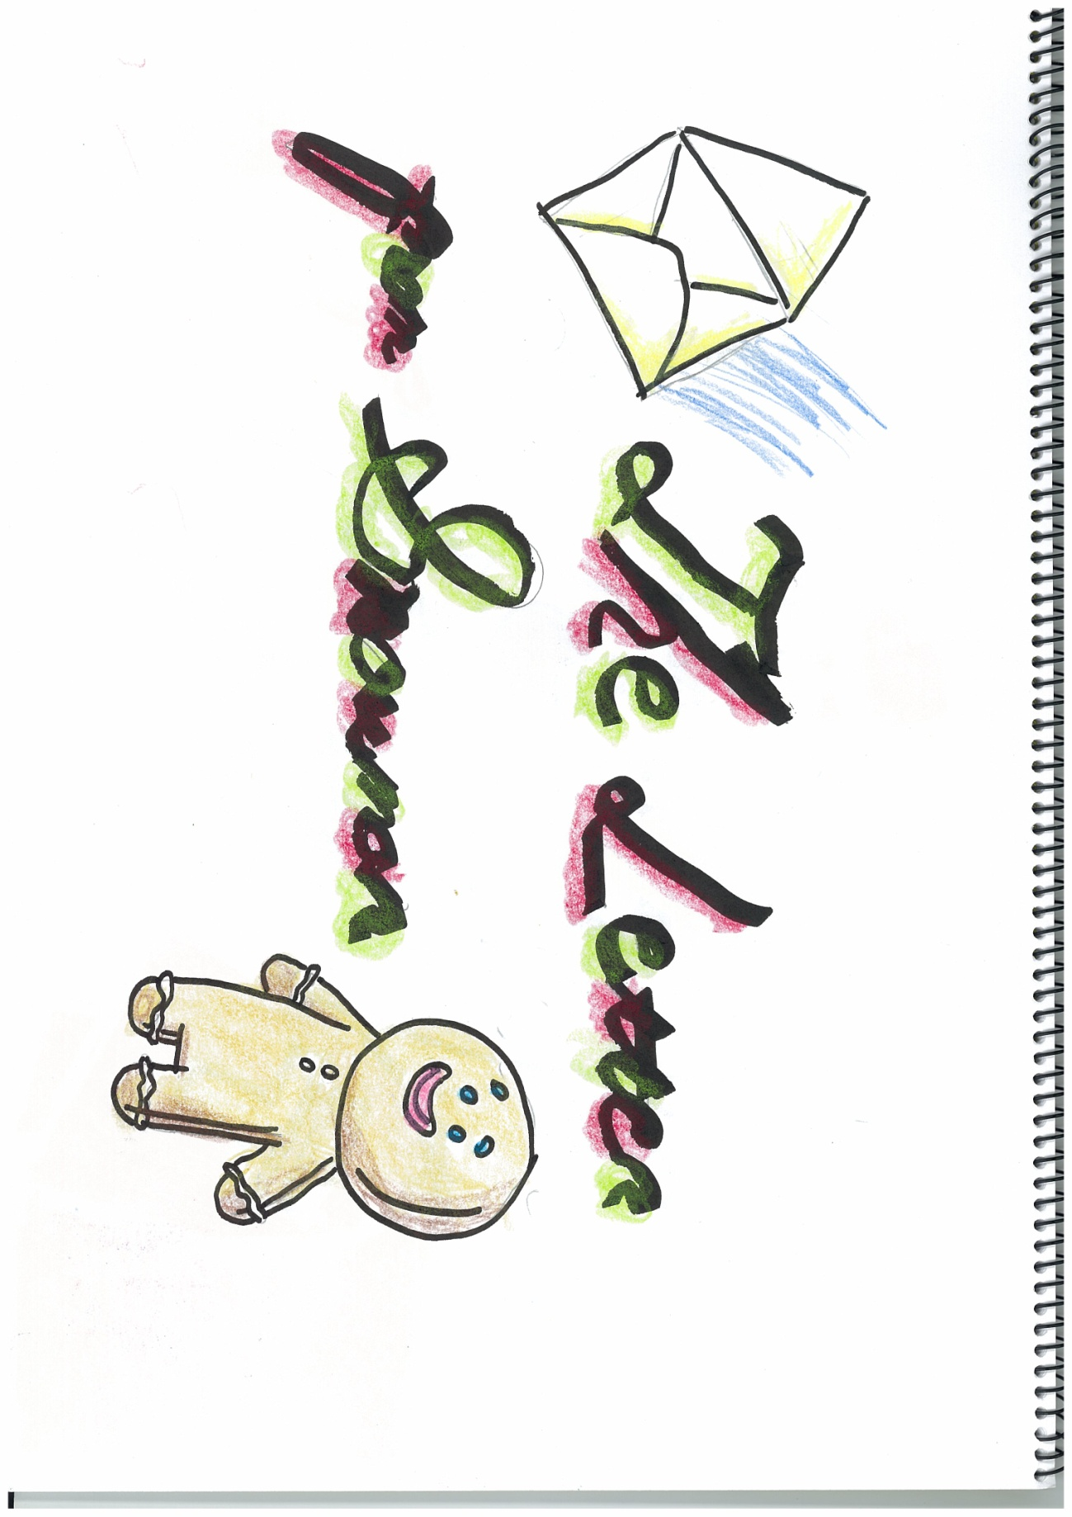

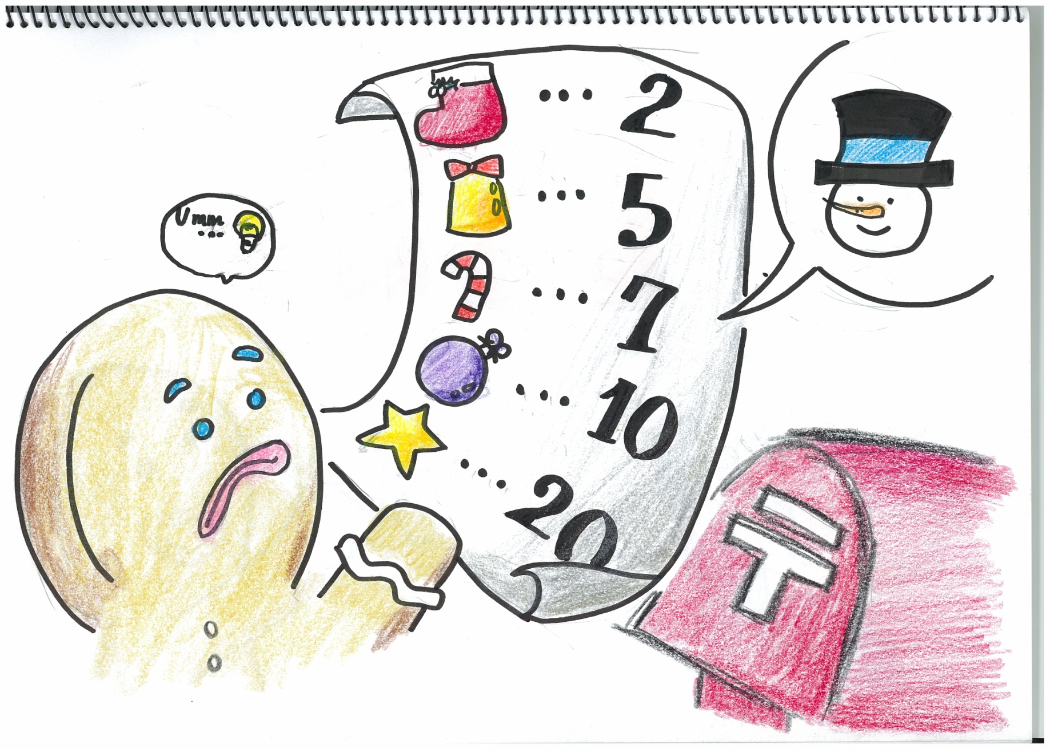

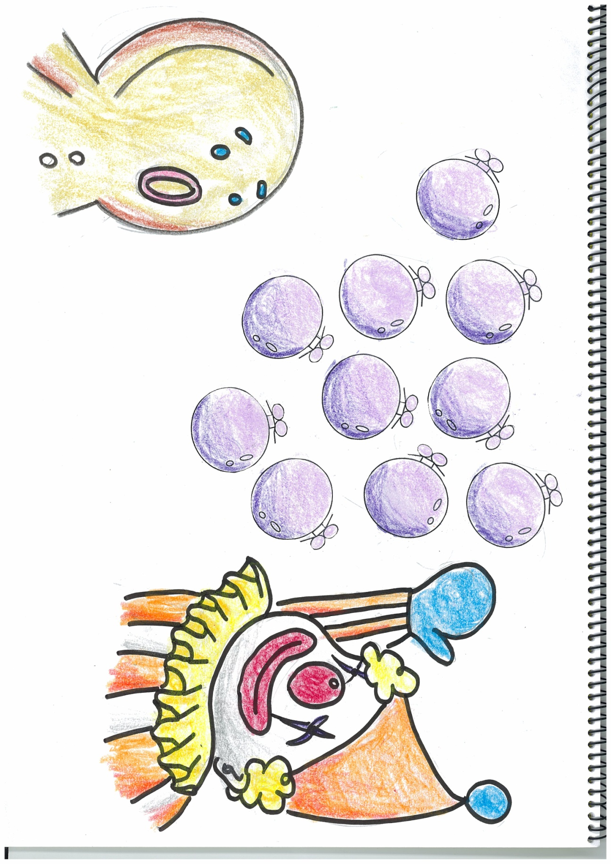
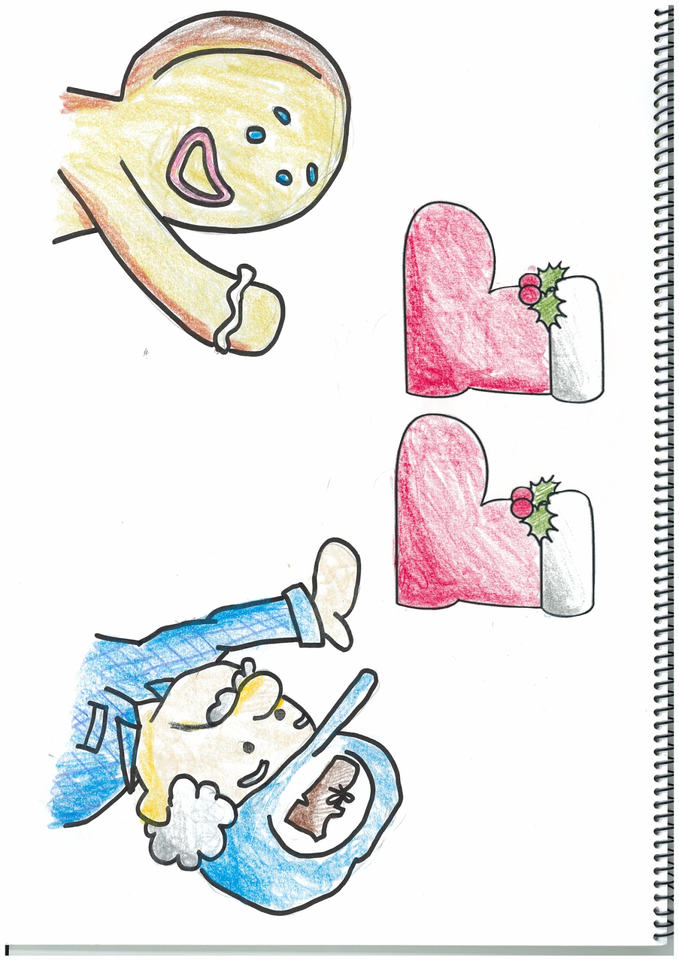

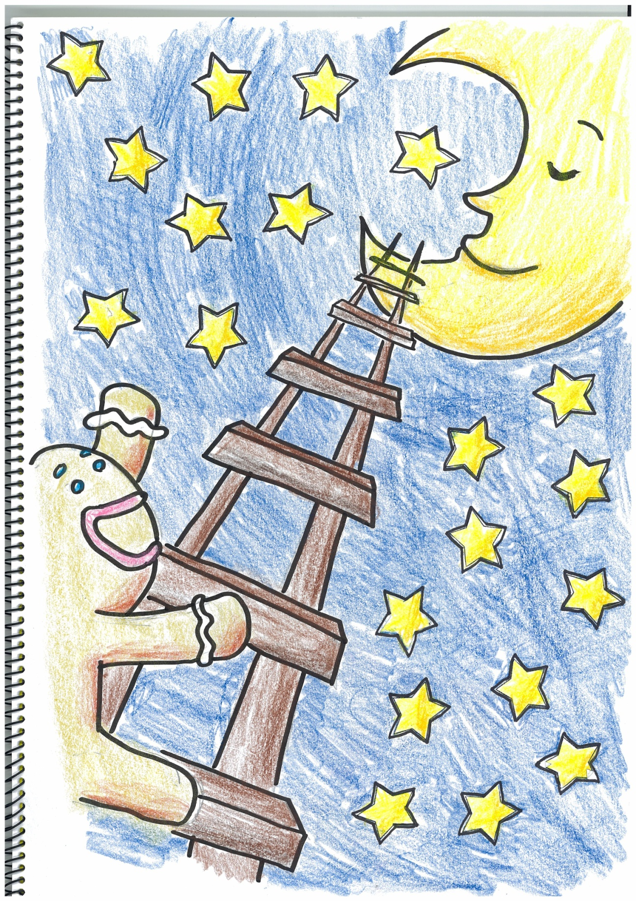
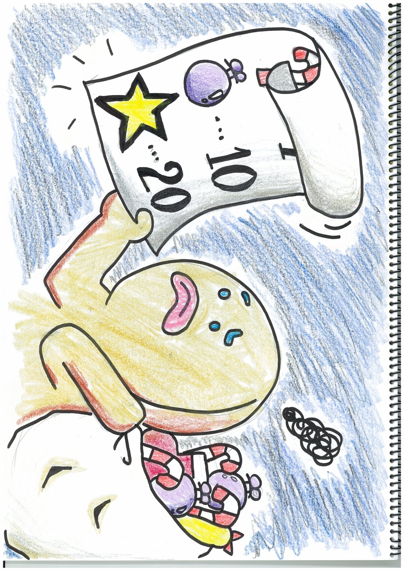

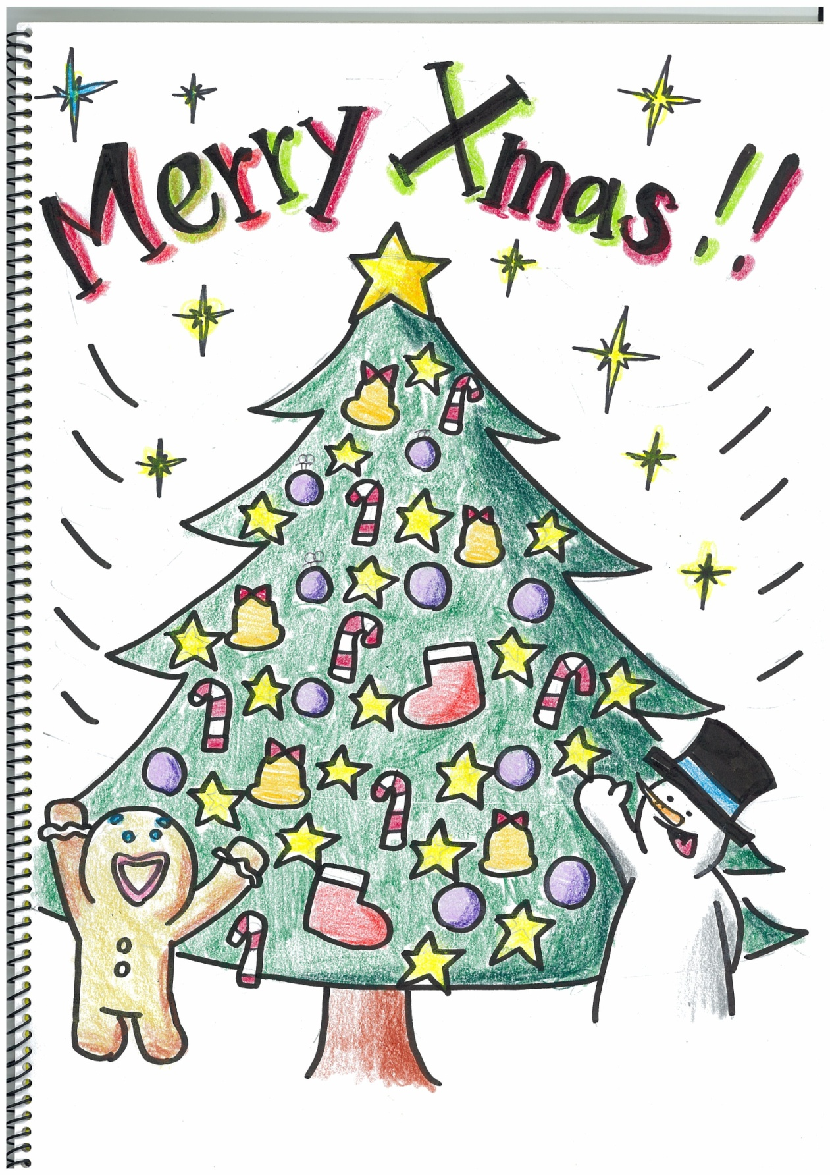
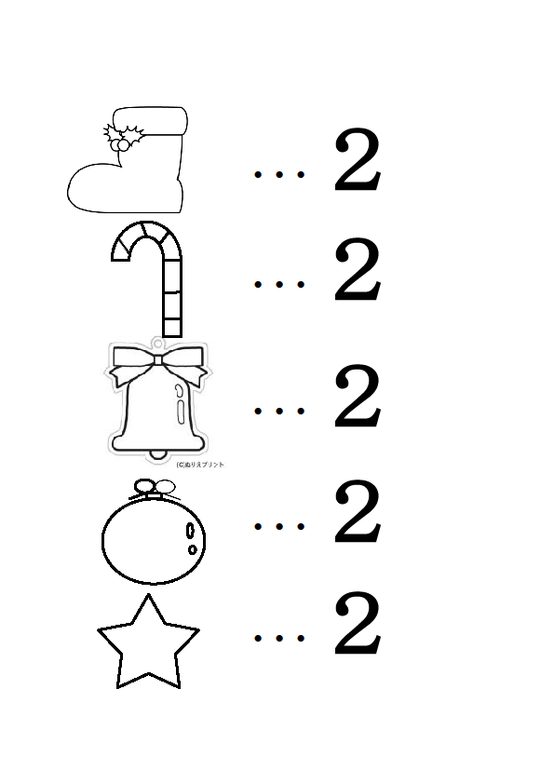

『The Letter from Snowman』

One day, Ginger bread man got a letter from his friend, Snowman.
The letter had a list and said “Please collect two boots, five bells, seven sticks, ten balls and twenty stars. After that, please come to the hill!”
So, he started collecting five kinds of ornaments.

First, he went to a shoe store to get two boots.
Ginger bread man: “Hello! Boots, please.”
Clerk: “How many?”
G: “Two, please.”
C: “OK. One, two. Here you are.”
G: “Thank you.”

Next, he went to church to get five bells.
G: “Hell! Bells, please.”
Priest: “How many?”
G: “Five, please.”
P: “OK. One, two, three, four, five. Here you are.”
G: “Thank you.”

Next, he went to an old people’s home to get seve n sticks.
G: “Hello! Sticks, please.”
Old people: “How many?”
G: “Seven, please.”
O: “OK. One, two, three… six, seven. Here you are.”
G: “Thank you.”

Next, he went to a circus to get ten balls.
G: “Hello! Balls, please.”
Clown: “How many?”
G: “Ten, please.”
C: “OK. One, two, three… nine, ten. Here you are.”
G: “Thank you.”

The last ornament was star, but he did not know where to go.
It was already dark. There was noboby around him. He felt lonely. He almost cried.
Suddenly, he heard a kind voice from the sky. “Are you OK?”
He looked up, and…

It was Moon! And there ware a lot of stars in the sky!
G: “Hello, Moon! Stars, please.”
M: “How many?”
G: “Twenty, please.”
M: “OK. One, two, three… ninety, twenty. Here you are.”
G: “Thank you!”

He had collected all ornaments, two boots, five bells, seven sticks, ten balls and twenty stars. He went to the hill. There was Snow man on the hill. Ginger bread man felt happy.

They had many ornaments, so they started decolating a tree. It was very interesting. It started snowing.

Finally, they made a wonderful Christmas tree! It was a white Christmas. G: “Merry Christmas, Snow man.”
Snow man: “Merry Christmas, Ginger bread man.”

