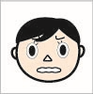
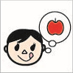
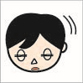

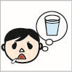

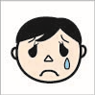
angry
name
name
name
name
name
name
name
sad
sleepy
tired
thirsty
happy
hungry

