Penguin  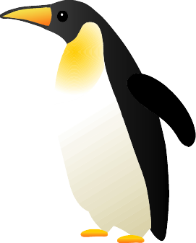  ○(I) swim  ×(I) fly | Turtle  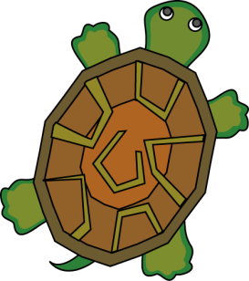  - (I) swim  - (I) walk  × (Y) run fast | Chicken  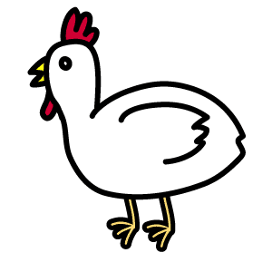  - (I) get up early  - (I) fly a little | Santa Claus    - (I) give you a present  ○(Y) see me once a year
Koala    - (I) sleep on a tree  × (I) run fast  ○(Y) see me in Australia | Camel  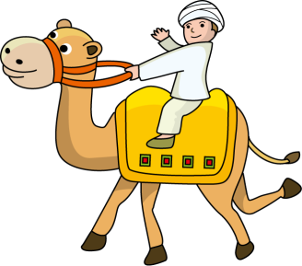  - (I) walk a long way.  - (Y) see me in Sahara | Horse  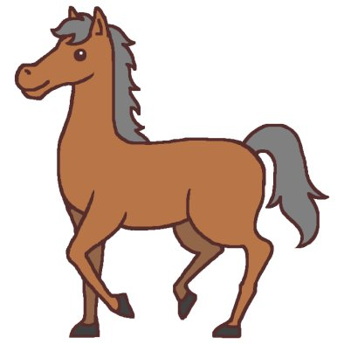  - (I) run fast  × (I) eat other animals  - (Y) see me at a race | Dog    - (I) run fast  - (I) play with people  × (I) speak language
Panda  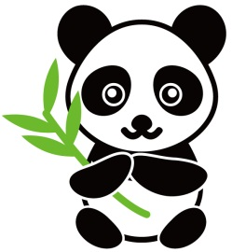  - (I) eat bamboos  - (Y) see me in China or Ueno zoo | Lion  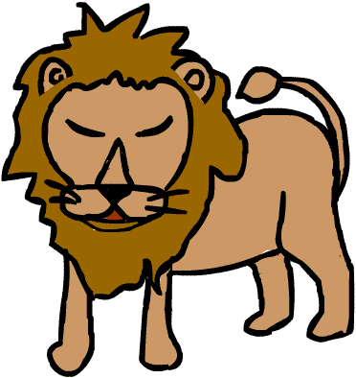  - (I) eat other animals  - (Y)see me in Africa | Elephant    ○ (I) use my nose well  ☆ (Y) see me in India | Monkey    ○ (I) use my tale well  ○ (I) eat bananas well.  ○ (Y)see me on a tree
Bear  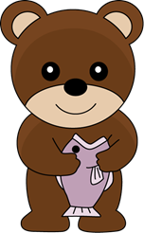  - (I) get salmon  - (I) sleep long time  ○(Y)see me in a mountain | Crab  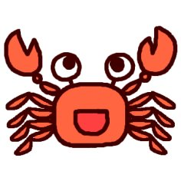  - (I) walk in water  - (I) cut | Umbrella    - (Y) open me  - (Y) see me on rainy days | Cloud    - (I) change the weather  ○(Y)see me almost all days  ×(Y) touch me
Nobita Nobi    ○ (I) do ayatori well  × (I) get up early | Monkey. D. Luffy    ○ (I) eat a lot  × (I) swim | Momoko Sakura  (まるちゃん)  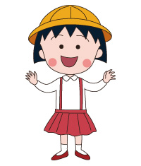  ○ (I) draw a picture well  × (I) get up early | Doraemon    - (I) help my friend  ×(I) play with mice
Jaian    ○ (I) sing loudly  × (I) sing well | Ryo Ishikawa  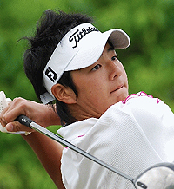  ○ (I) play golf  ○ (I) speak English well | Ichiro  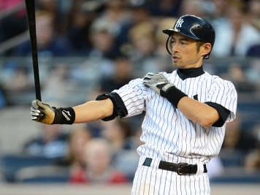  ○ (I) hit a ball well  ○ (I) speak English | Miki Ando    ○ (I) dance on ice  ○ (Y) see me at Chukyo University
Book    - (Y) open me  ○ (Y) close me  ○ (Y) read me | Ship  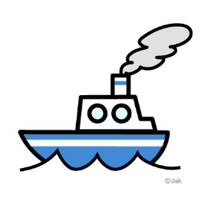  ○ (Y) see me at the sea  × (I) swim  - (I) take many people somewhere | Snow  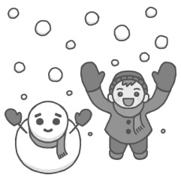  ○ (Y) see me in winter  ○(Y) not see me in summer  ○(Y) play with me | Airplane    - (I) fly  × (I) swim  - (I) cross the ocean
Newspaper  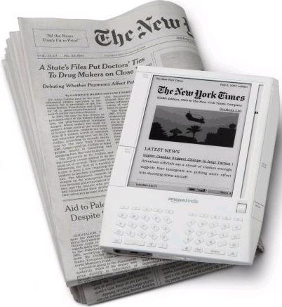  - (I) tell you news  - (Y) see me everyday | Signal(信号機)  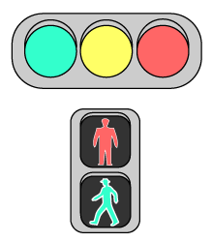  ○ (I) stop you  × (I) move  ○(Y) see me on a road | Stars    - (Y) see me at night  × (Y) see me in noon | Fire  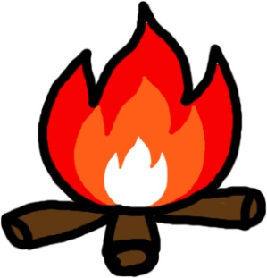  ○ (Y) cook with me  ○ (I) kill you  ×(Y) touch me

