  eat natto | 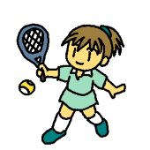  play tennis |   cook curry |   drive a car
  read  English books |   run fast | 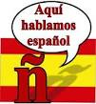  speak Spanish |   swim well
  get up early | 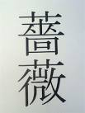  write ばら  in kanji

相手ができないと言ったことの欄にサインをしてもらおう！
例）自分はI can eat Natto. のカードを持っていて、相手がI can’t eat Natto. と答えたら、eat
Natto の欄にサインをもらう。

can’t | name | can’t | name
eat Natto |  | read English books
play tennis |  | run fast
cook curry |  | speak Spanish
drive a car |  | swim well
get up early |  | write ばら in Kanji

