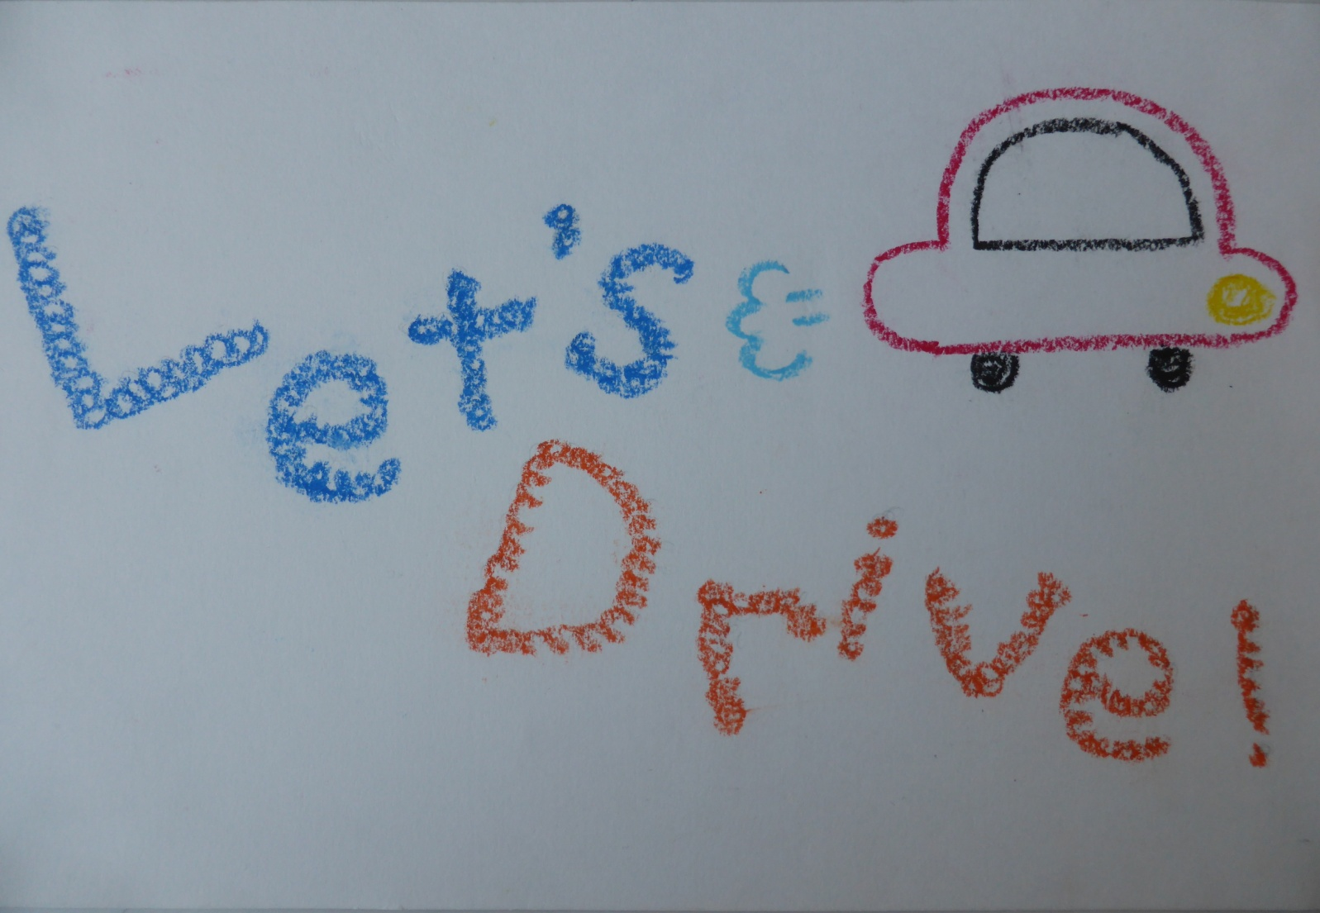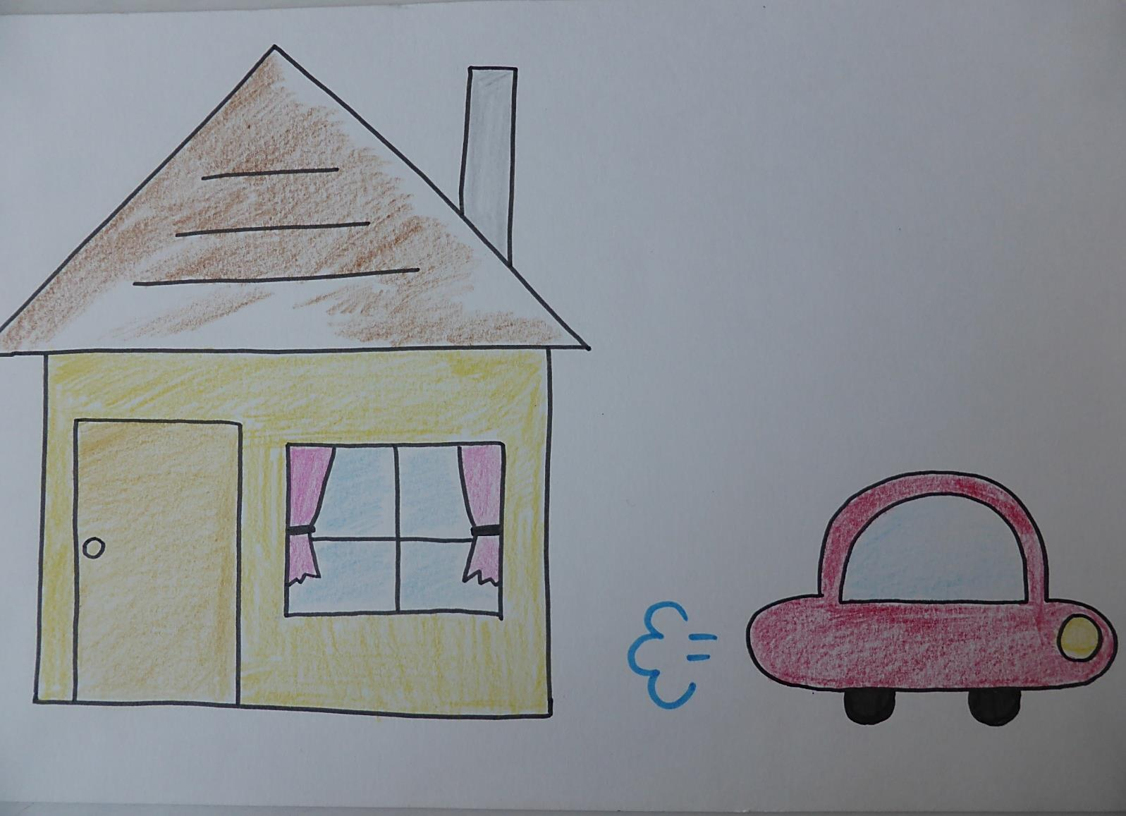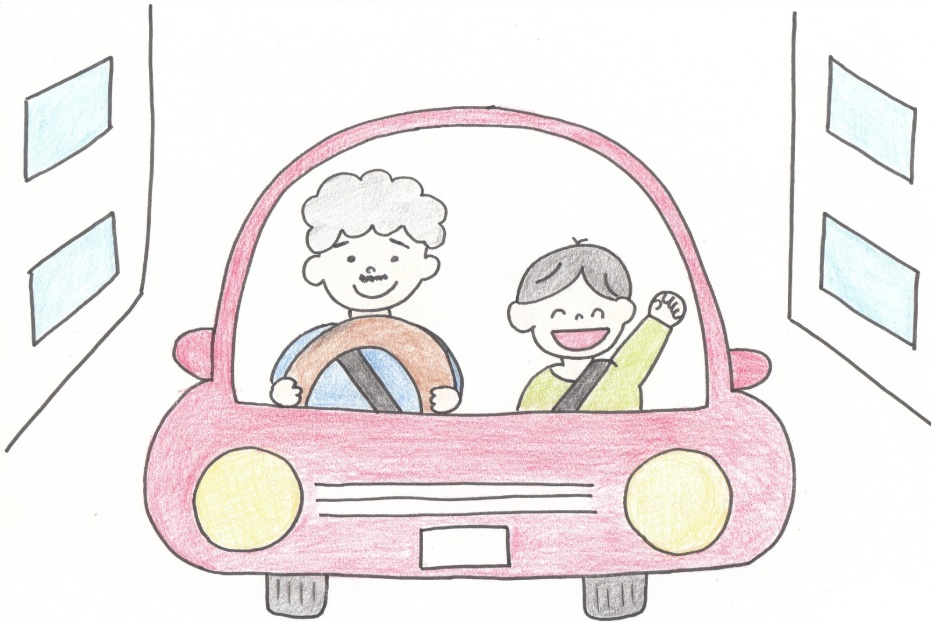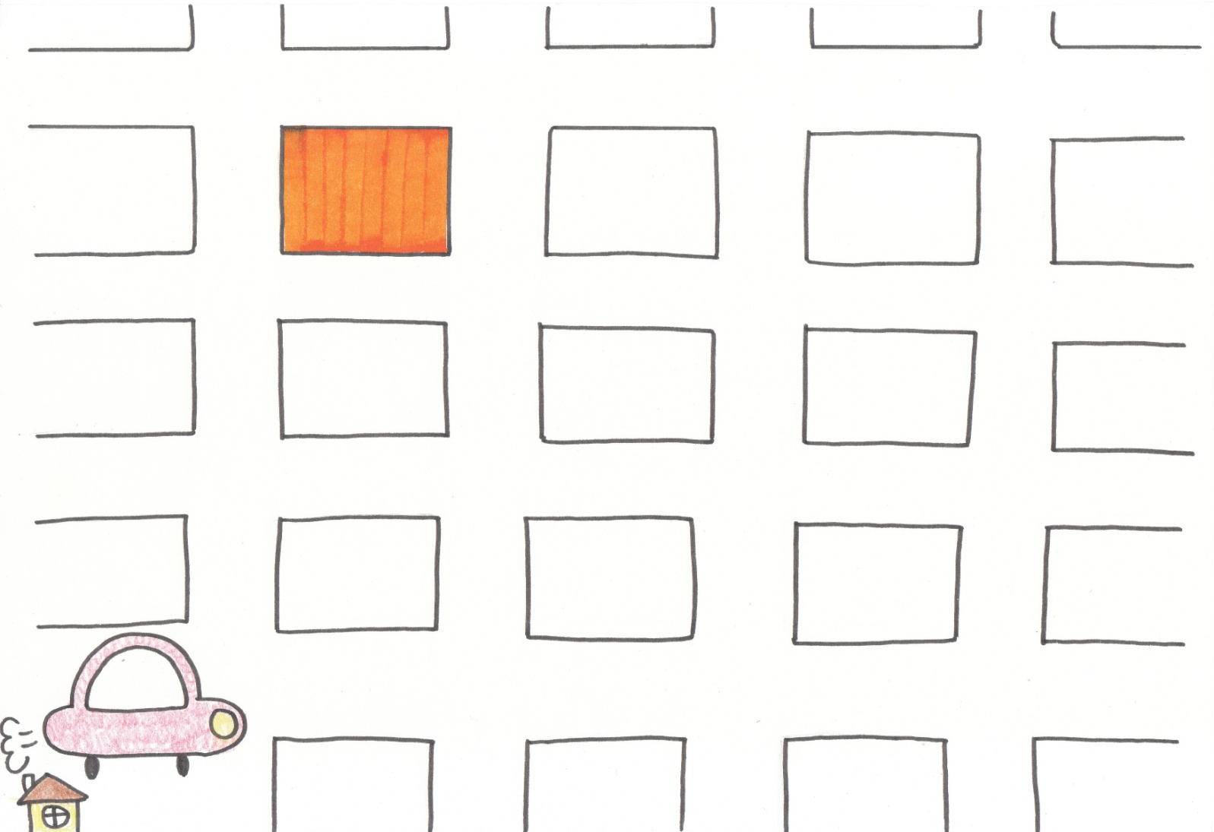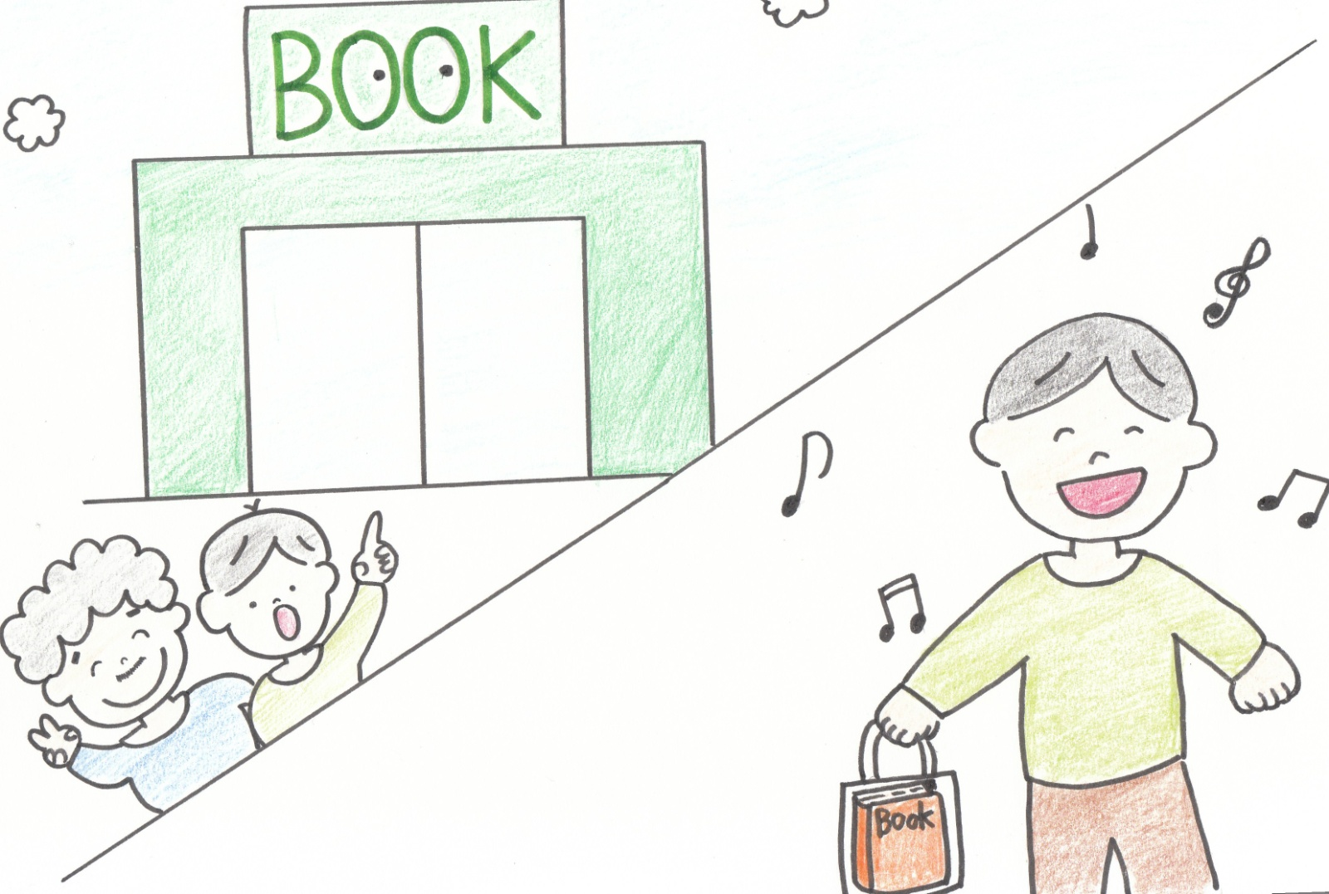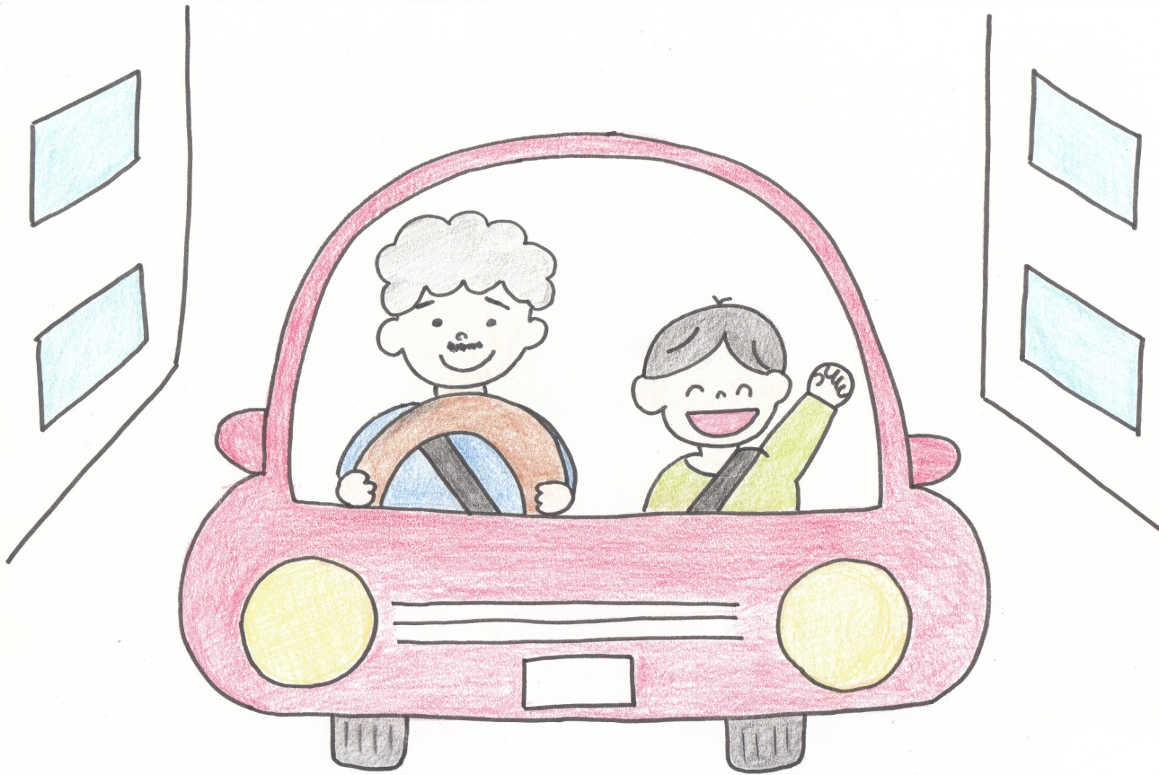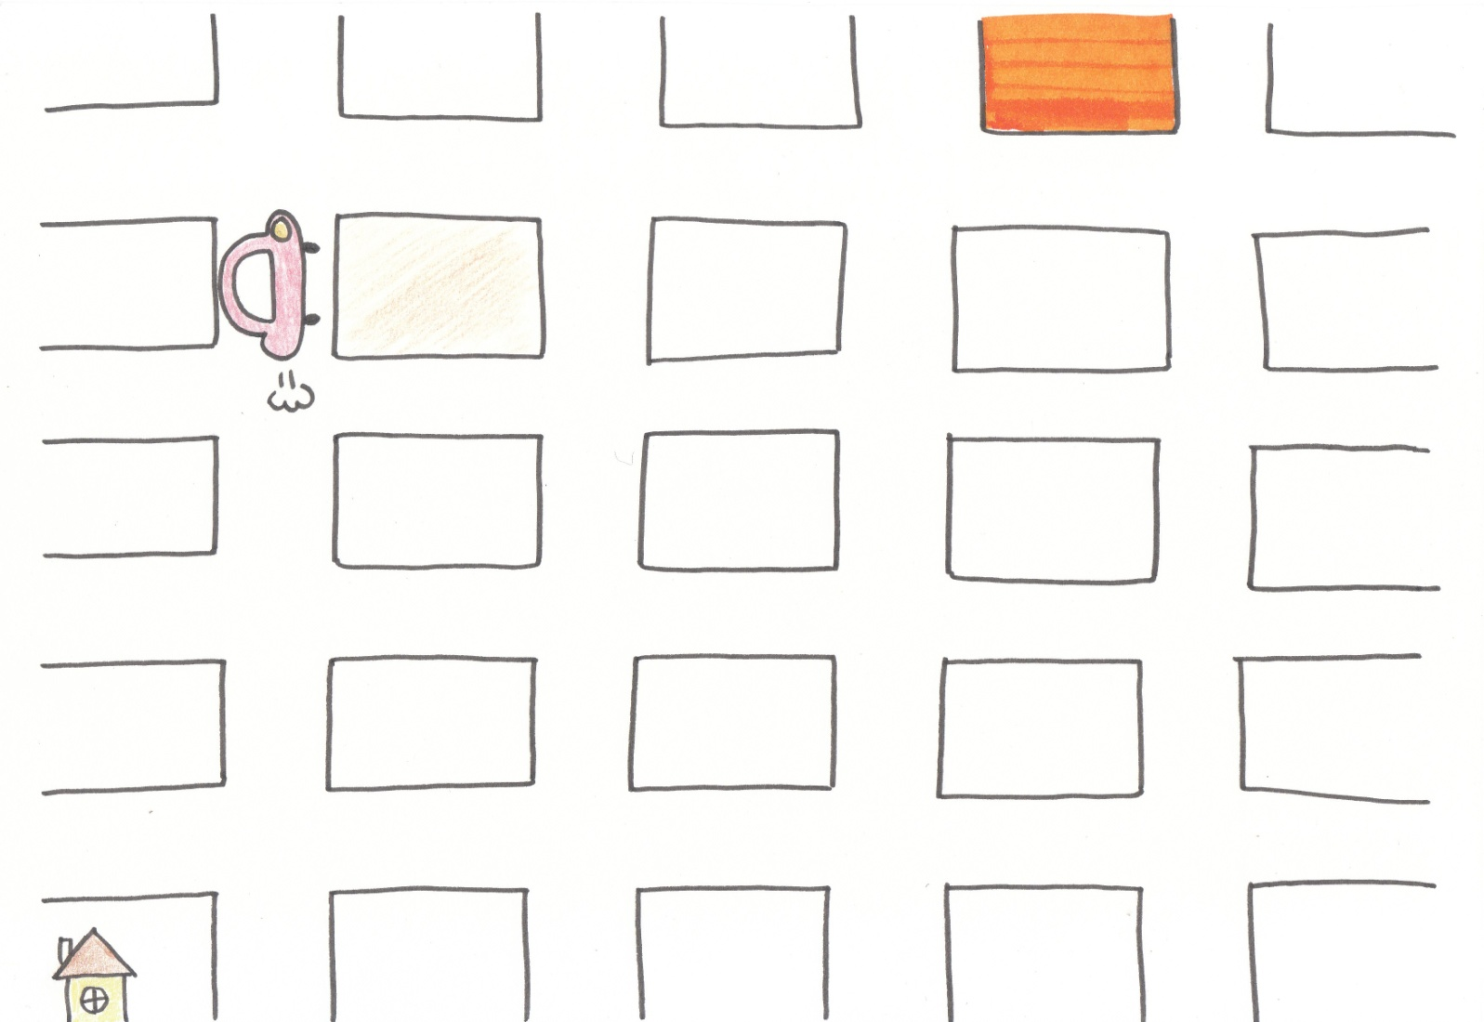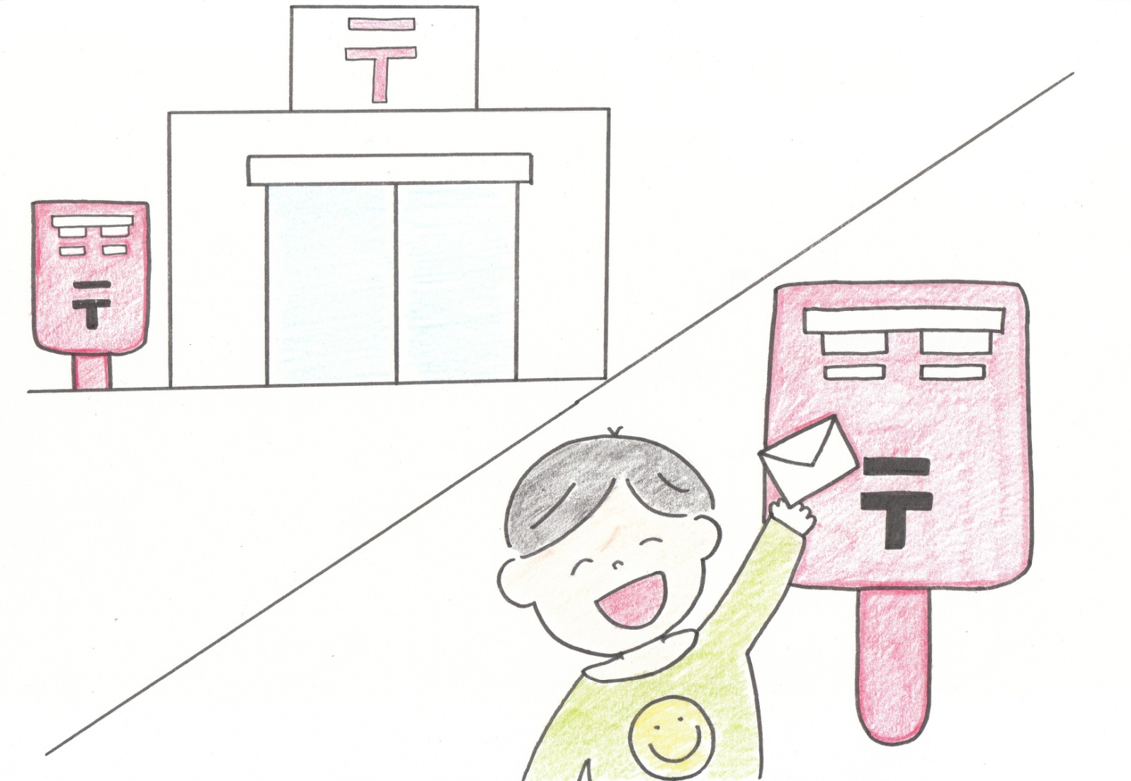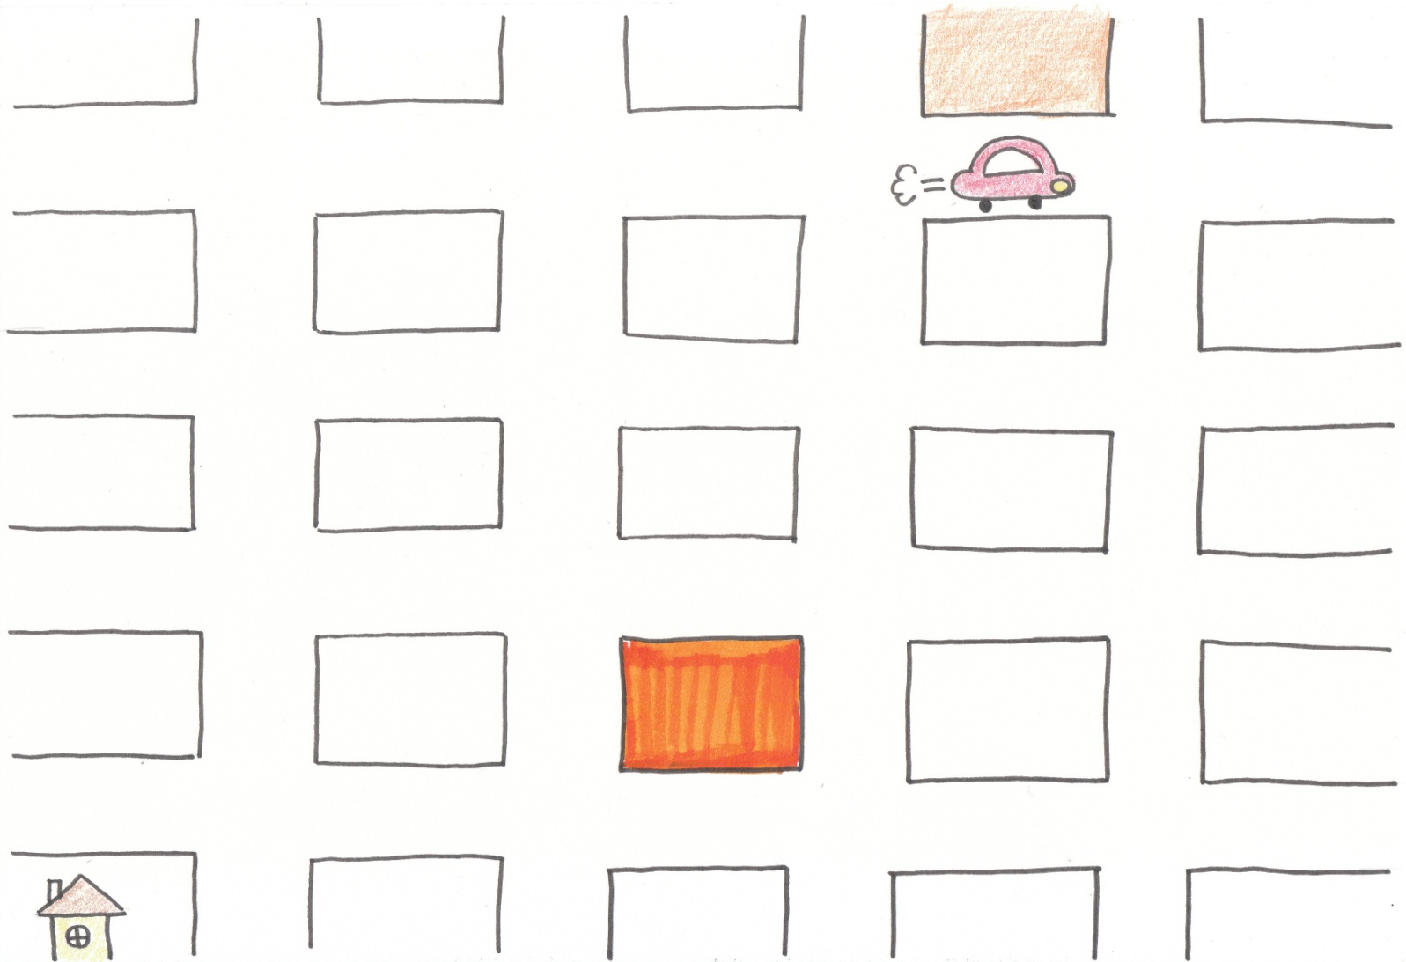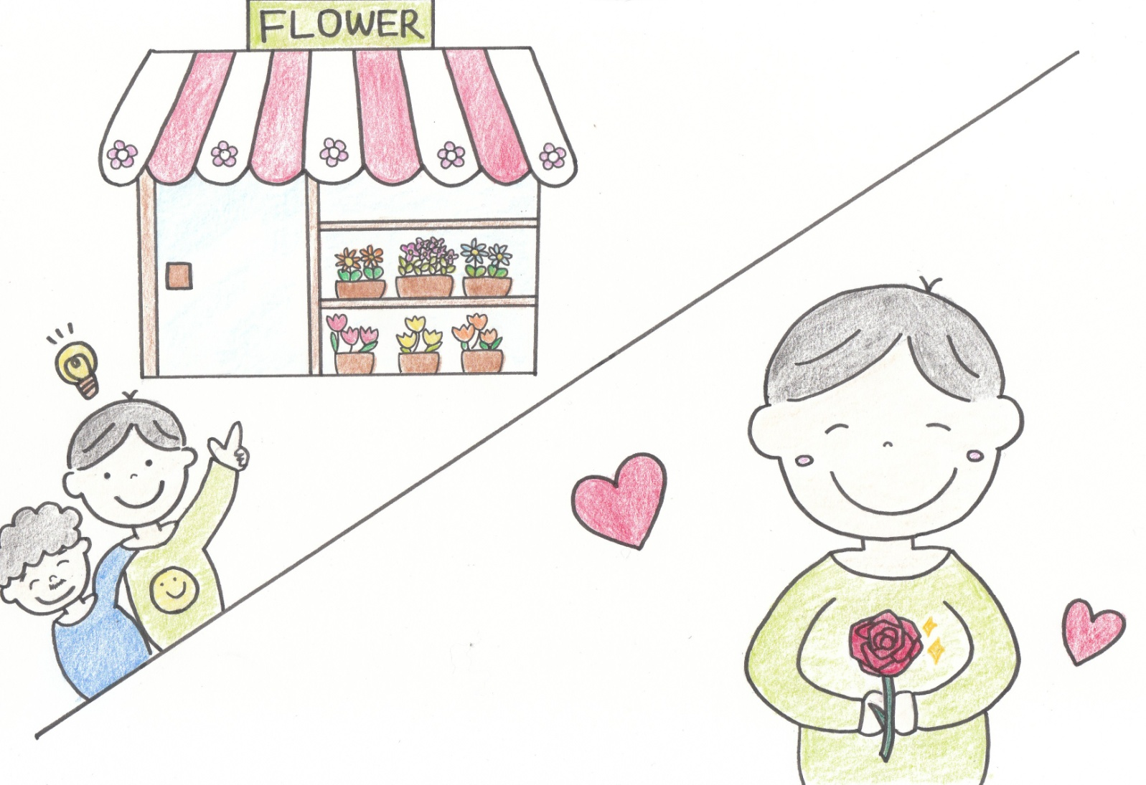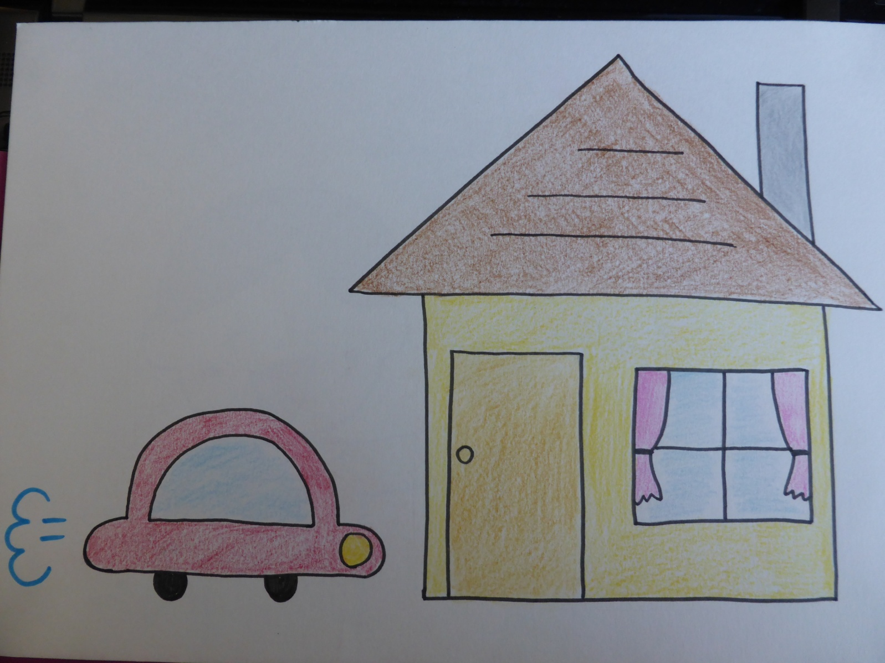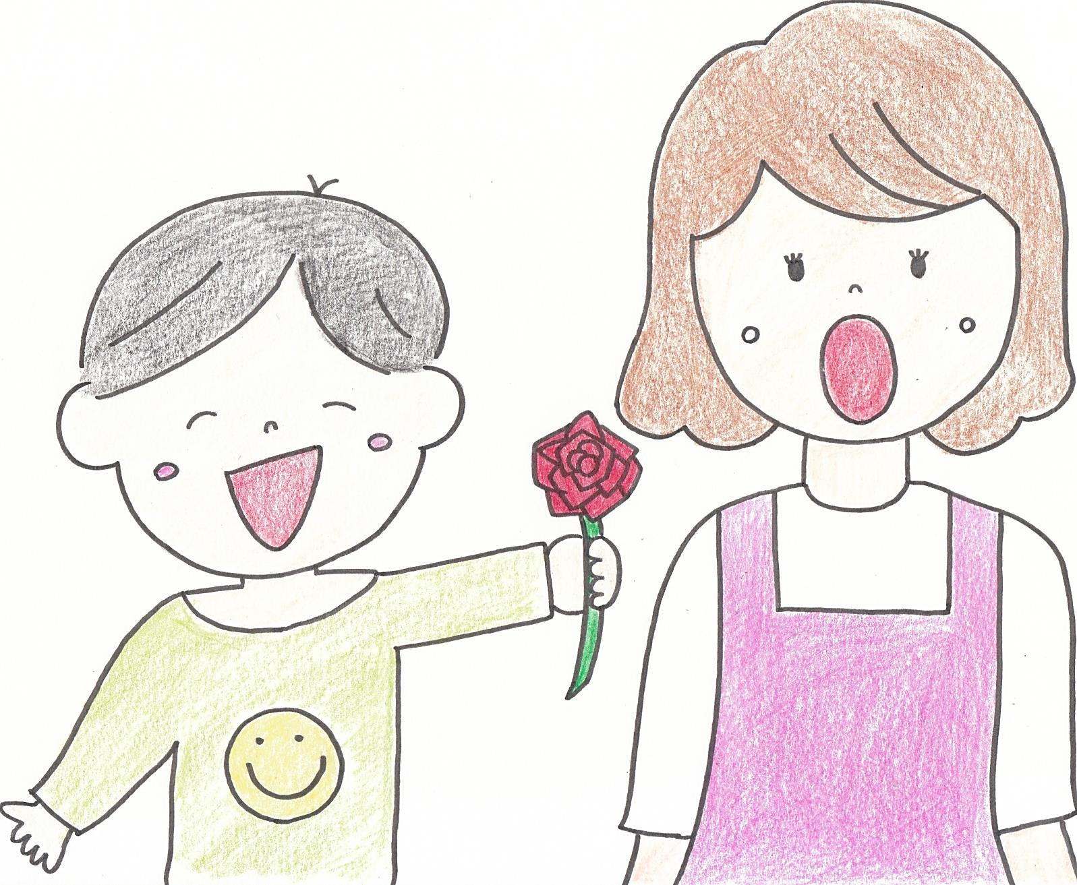

p.1『Let's Drive』 著者：Shuhei Ota, Ayano Noguchi
p.2 One day, Takashi's father said to Takashi,
Father: "Let's drive!!"
Takashi:"OK."
Then they left their house.

p.3 F:"Where do you want to go?"
T:"Book store!!"
F:"OK."
His father asked the car navigation.
F:"Where is the book store?"

p.4 Car navigation:"Turn left and go straight for three blocks. You can see the book store on your right."

p.5 They arrived at the book store.
Takashi got a new book.

p.6 F:"Where do you want to go next?"
T: "Post office."
His father asked the car navigation,
F:"Where is the post office?"

p.7 C:"Turn right and go straight for three blocks. You can see it on your left."
They arrived at the post office and Takashi posted his letter to his friend.

p.8 F: "Where do you want to go next?"
T: "Flower shop!!"
F: Where is the flower shop?"
p.9 C: Turn right and go straight two blocks. And turn right and go straight for two blocks. You can see it on your left."

p.10 They arrived at the flower shop. Takashi got beautiful flowers for mother.

p.11 Finally, they arrived at his house.

p.12 Takashi gave his mother flowers!

