11. 受け身 be ～ed by______.
_______によって～される。

目標：タスクを通じて受け身の肯定文が使えるようになる。
対象：中学３年生
時間：25分
準備：写真（黒板掲示用）、絵カード（カードゲーム用）

このタスクの進め方
○ Pre-task
１．教師が写真を見せながら生徒にそれが何かを尋ね、生徒に答えてもらう。その後生徒に質問をしながら受け身の文を導入する。なお、この会話文はいくつか行う。
（例） T: (写真を見せながら)Do you know it?
S: Mickey Mouse!
T: Yes! This is Mickey Mouse.
Do you like it? (多くの人に聞く)
S: Yes. / No.
T: Yes. I also like Mickey Mouse.
So, Mickey Mouse is liked by many people.

y people.

２．黒板に受け身の文を書いて、生徒に受け身の文を考えさせた後、受け身の文の言い方に気づかせる。
○ Task
１．５人１組のグループを作る。
２．20枚のカードを中心に裏向きにして重ねておく。
３．１人がカードに書いてあるものの説明を受け身を使ってする。
（例）This is a stationary. It is used by many people to take notes.
４．他の4人はそれが何を説明しているものか当てる。
５．当てた人は説明をした人からそのカードをもらえる。
６．一番多くのカードを集めた人の勝ち！
ワンポイント・アドバイス
・難しい単語には注釈をカードにつけてあるため、ヒントの時に注釈の意味を言わせる。
・カードには受け身にする文も能動態で書いてあるため、最初のほうは教師が補助をしてあげるといい。

Notebook  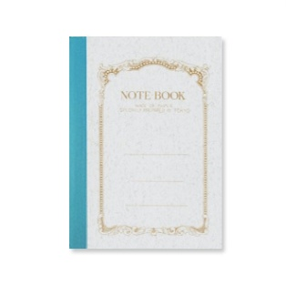  This is a stationary.  Many students use it to take notes.  *take-took-taken | Calendar  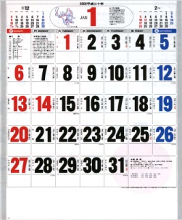  This is a stationary.  People hang it on the wall.  *hang…掛ける  *hang-hung-hung | Banana  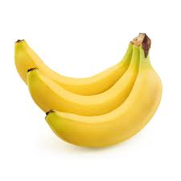  They are fruits.  People in New Zealand make them.  *make-made-made | Blackboard  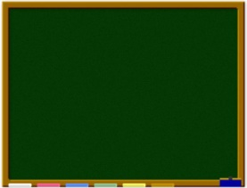  This is a school thing.  Teachers use it at the classroom.
Tom Sawyer  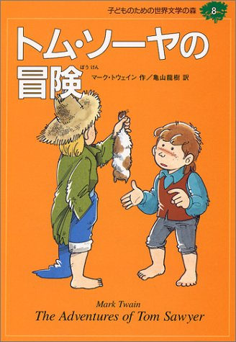  This is a book for children.  Mark Twain writes it.  *write-wrote-written | Bocchan  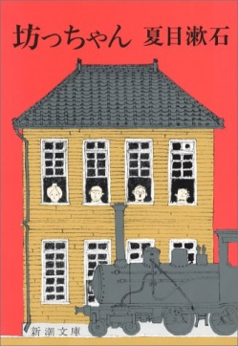  This is a book.  Soseki Natsume writes it.  *write-wrote-written | One Piece  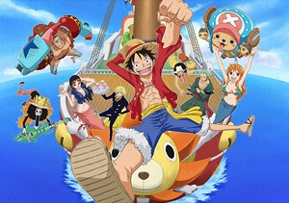  This is a famous comic book.  Oda Eichiro writes it.  *write-wrote-written | NARUTO  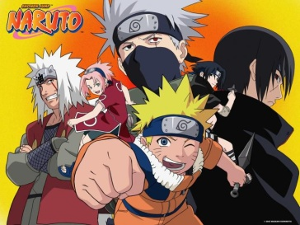  This is a comic book.  JUMP comic publishes it.  *publish…掲載する
Nobita  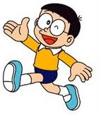  This is a character.  Doraemon helps him. | Mickey Mouse  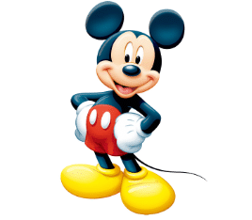  This is a character.  Walt Disney makes it.  *make-made-made | Kumamon  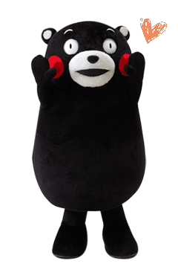  This is a character.  People in Kumamoto like it. | Funassyi  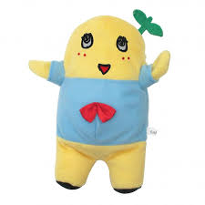  This is a character.  The city does not allow it an official character.
Sekkaini hitotsudakeno hana  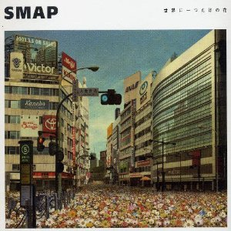  This is a famous song.  SMAP sings it.  *sing-sang-sung | Arashi  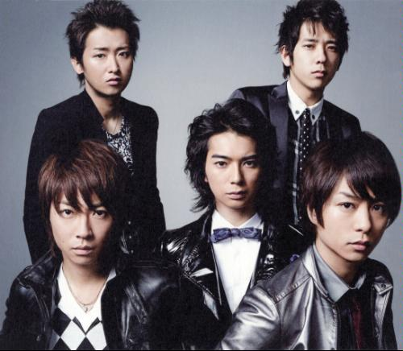  This is a Junney’s idol group.  They sing “Love so Sweet”  *sing-sang-sung | Rino Sashihara  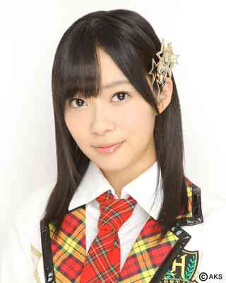  She is a singer.  Many people call her Sassyi. | Kai kun (father’s dog)  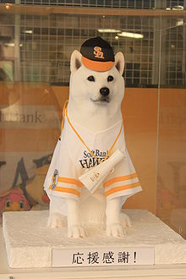  This is a dog.  Softbank’s CM uses him.
Tokyo Banana  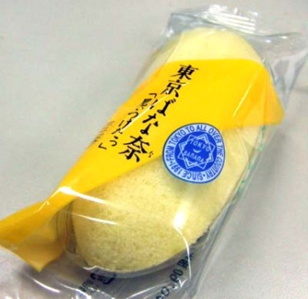  This is a sweet.  Many people buy it at Tokyo station. | Shiroi koibito  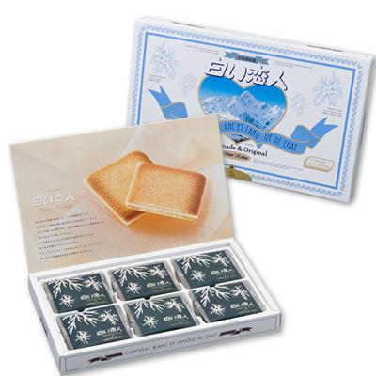  This is a souvenir.  Many shops in Hokkaido sell it. *souvenir…土産 | Tinsukou  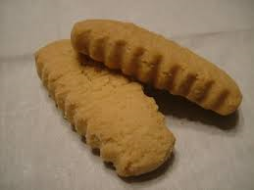  These are Japanese sweets.  People in Okinawa often eat it.  *eat-ate-eaten | Students  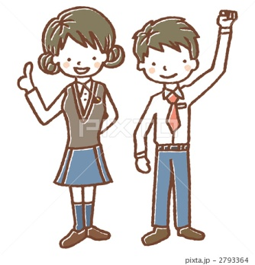  These are people.  Teachers teach them some subjects at school.  *teach-taught-taught

