現在完了（経験）を理解しよう！

We have joined Kouhaku-Utagassen in NHK.
（訳 ）

現在完了形が“経験”で用いられるときの意味は（～ ）となる。現在完了形をつくるときは、have+（ ）の形である。

Ｈａｖｅ ｙｏｕ joined Kouhaku-Utagassen in NHK？

また疑問文をつくるときは（ ）を頭に出す。

Have you ~? Yes, I have./No, I have not.
かるた取りをしよう！
<ルール>
- じゃんけんをして読み手と取り手を決めよう。
- 読み手が読んだ文章を聞いて、取り手は聞き取った情報と一致していると思ったかるたを取ろう。ただし、お手つきは一回休みです。
- 答え合わせ後、読み手が取り手に現在完了の文を用いて質問をして、Yes/Noでその内容に関して正確に答えることができればそのかるたを取ることができます。
- たくさんかるたを取ることのできた人を勝ちとします。

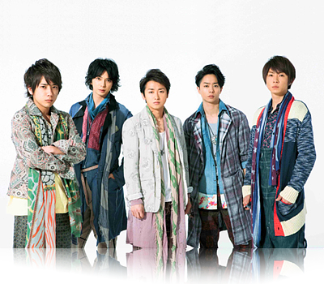 | 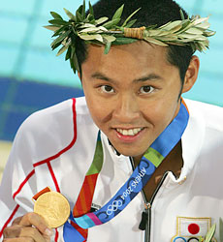 | 
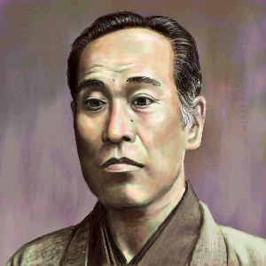 | 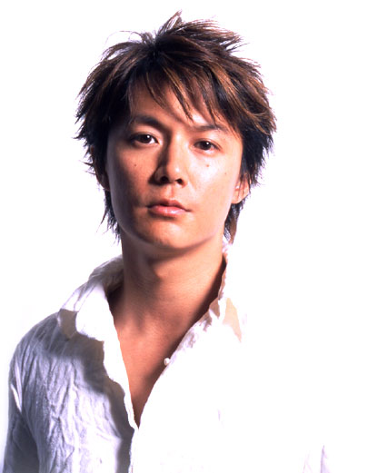 | 
 | 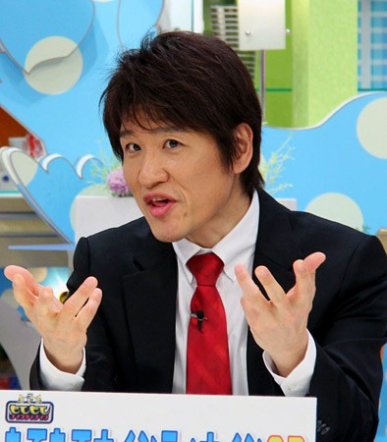 | 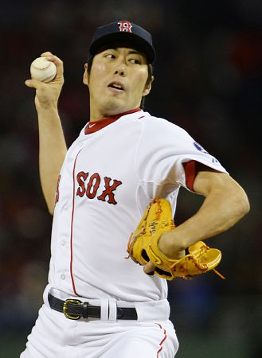
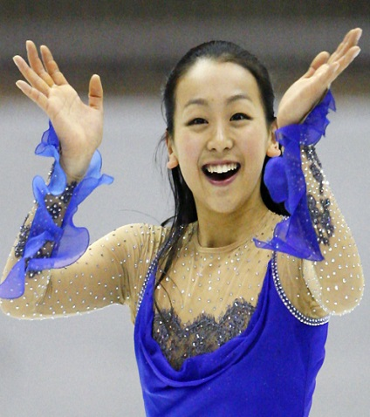 | 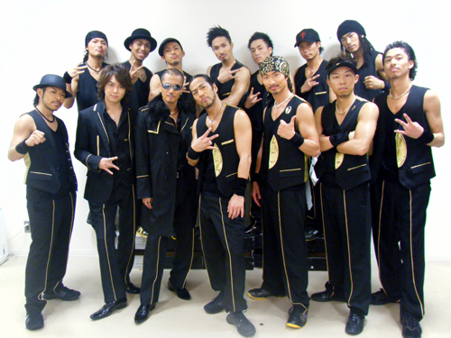 | 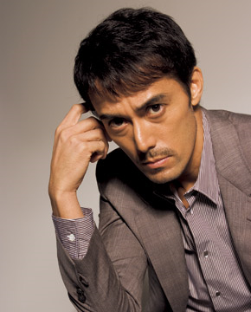
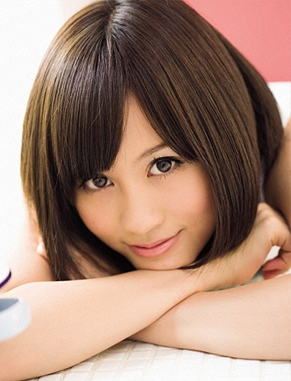 | 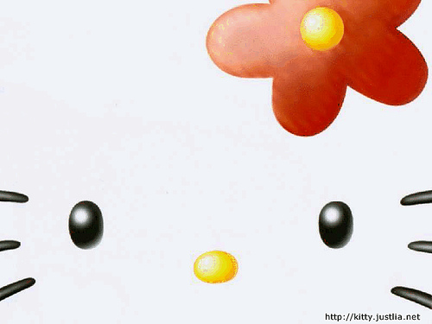 | 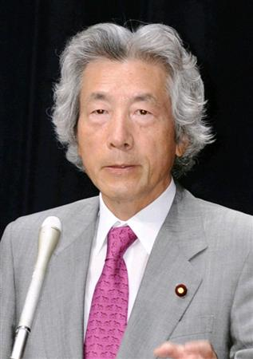
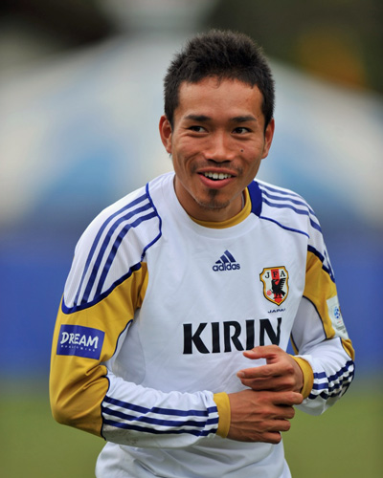 | 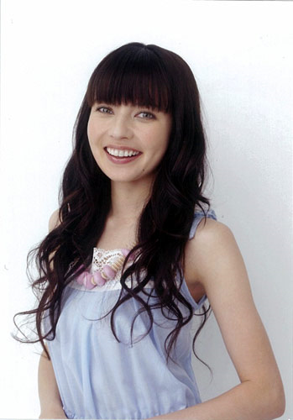 | 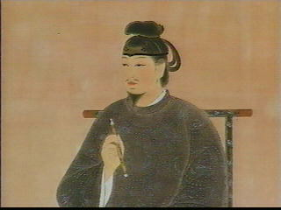
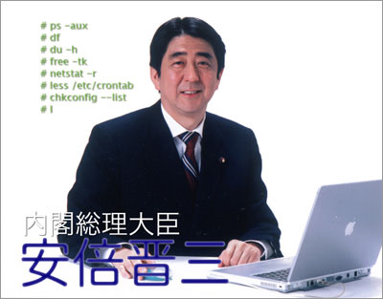 | 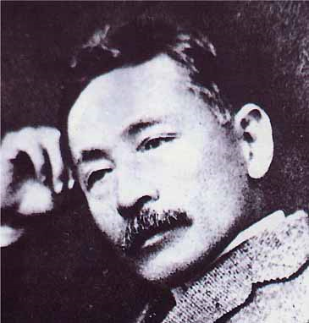 | 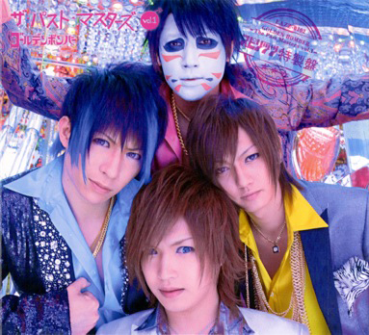
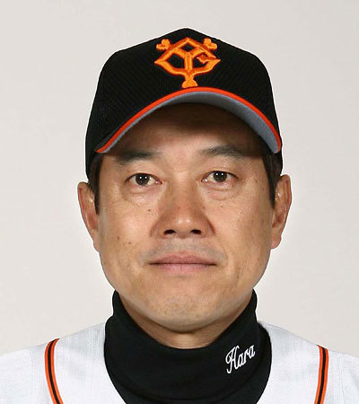 | 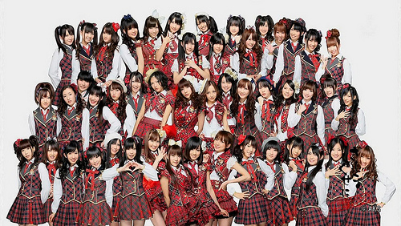 | 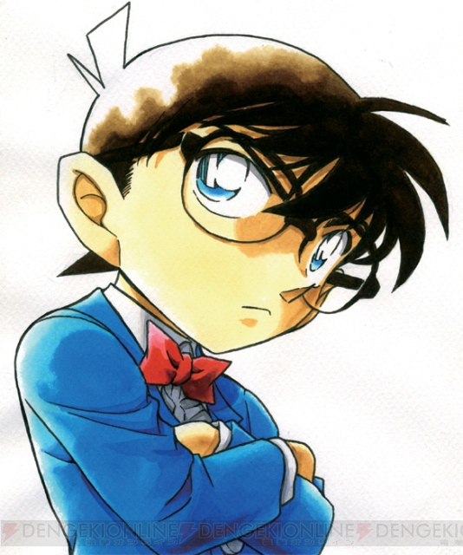

○We have joined 24 hours TV 4 times.  ○We are idol team.  ○We have 5 members.  (Arashi) | ○I have solved many cases(事件).  ○I was a high school student.  ○Now I am an elementary school student.  (Konan) | ○We have joined Kouhaku-Utagassen in NHK.  ○We are dance and vocal group.  ○The famous song is cho-cho train.  (EXILE)
○I have got gold medals.  ○I am a man.  ○I practice swimming every day.  (Kosuke Kitajima) | ○We have become No.2 in M1.  ○We are comedians.  ○The famous gag is “tooth”.  (Odori) | ○I have appeared one movie, trick.  ○I am an acter.  ○I have been a model.  (Hiroshi Abe)
○I have been written on money.  ○I have written a lot of books.  ○The famous book is Gakumon no susume.  (Yukichi Hukuzawa) | ○I have been the Prime Minister twice.  ○I am going to raise the rate of consumption tax(消費税の割合).  ○My uncle is Nobusuke Kishi.  (Shinzou Abe) | ○I have joined a team.  ○I am a woman.  ○I have been the center of AKB 48.  (Atsuko Maeda)
○I have appear(出演する) the TV drama, Garireo.  ○I am an actor.  ○I sing many songs.  (Masaharu Hukuyama) | ○I have written a lot of books.  ○I was in 1000yen.  ○The famous book is 坊っちゃん.  (Soseki Natume) | ○I have been a character of USJ.  ○I am a character.  ○I have a boyfriend, Daniel.  (Hallo Kitty)
○I have transferred different club teams.  ○I am a soccer player.  ○I play soccer in AC miran.  (Keisuke Honda) | ○We have done live concerts.  ○We have 4 members.  ○We play the air-gaiter.  (Golden Bomber) | ○I have become a prime minister.  ○I have a famous son.  ○The son’s name is Shinjiro Koizumi.  (Junichiro Koizumi)
○I have helped a person many times  ○I am a character.  ○My friend is Nobita.  (Doraemon) | ○I have taught math in a clam school.  ○Now I teach Japanese writing.  ○I often say “when do you do it? Now.”(いつやるの？今でしょ)  (Osamu Hayashi) | ○I have played soccer in a Japanese club team.  ○Now I am in Italy.  ○The club team is “interu”(インテル)  (Yuto Nagatomo)
○I have been a baseball player.  ○I became the champion in Japanese baseball games.  ○I am a manager in Yomiuri Giants.  (Tatunori Hara) | ○I have played baseball in Japan.  ○I won many the baseball games  ○I join red socks now in Boston.  (Koji Uehara) | ○I have appeared in different TV programs.  ○I have a sister.  ○I am an entertainer.  (Bekky)
○We have elected No.1 many times.  ○We are an idol team.  ○we have sung flying get.  (AKB48) | ○I have joined the Olympic Games.  ○I have a dog.  ○I am a skater.  (Mao Asada) | ○I have built shrines in Japan.  ○I was in 10000yen.  ○I lived in the Asuka era.  (Shotokutaishi)

