分詞を理解しよう！
<過去分詞>
Cheese is a food. ＋ It is made from milk.
↓
Cheese is a food made from milk.
意味…( )

訳：チーズは牛乳から( )食べ物です。

<現在分詞>
Whale is the largest animal. ＋ It lives in oceans.
↓
Whale is the largest animal living in oceans.
意味…( )

訳：鯨は海洋に( )最も大きな動物です

☆過去分詞・現在分詞は前の名詞を説明する形容詞的な働きをする。過去分詞が用いられている時の意味は (① )となる。一方、現在分詞が用いられている時の意味は(② )となる。

Memo

～Card Game～ 現在分詞 過去分詞
<Rules>
- じゃんけんをして順番を決めよう。
- じゃんけんに勝った順に、説明カードを取って説明を読みあげよう。
- 説明を聞き、答えがわかったら、答えカードを取って現在/過去分詞の文を用いて答えを言おう。
- 言った文が答えカードの裏に書かれた正しい文と合っていたらそのカードをget、間違っていたらカードを元に戻そう。
- 制限時間内にカードを一番多く取れた人の勝ち！

<説明カード>
・This is the company.  ・It is built by Kiichirou Toyoda. | ・This is the man.  ・He plays soccer in  the team, Intel. | ・This is a drink.  ・It is made from rice. | ・This is the man.  ・He performs Kinpachi-sensei  *perform:演じる.
・This is a food.  ・It is made from  soybeans. | ・This is the largest animal.  ・It lives on the earth. | ・This is the movie.  ・It is watched by  many people all  over the world. | ・This is the woman.  ・She skates very  well.
・This is the book.  ・It was written by  Yukichi Hukuzawa. | ・This is the man.  ・He sends presents  to children. | ・This is a food.  ・It is eaten by many  people in Shizuoka and Tochigi. | ・This is the woman.  ・She appears the TV  program, Zip.  ＊appear:出演する
・This is the cellphone.  ・It is made by Apple. | ・This is the smallest animal.  ・It lives on land. | ・This is the book.  ・It was written by  Ryuunosuke Akutagawa. | ・This is the strongest animal.  ・It lives on Savanna.

<答えカード>
Toyota  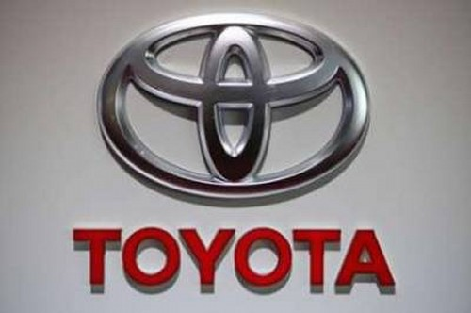 | Yuuto Nagatomo   | Sake(日本酒)  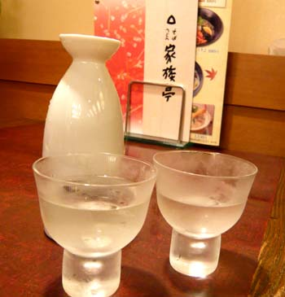 | Ｔｅｔｕｙａ Ｔａｋｅｄａ  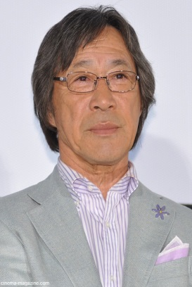
Ｔｏｆｕ  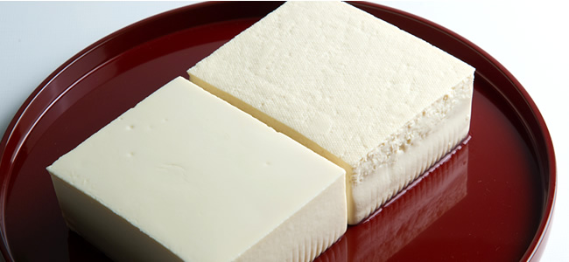 | Ｂｌｕｅ ｗｈａｌｅ  （シロナガスクジラ）  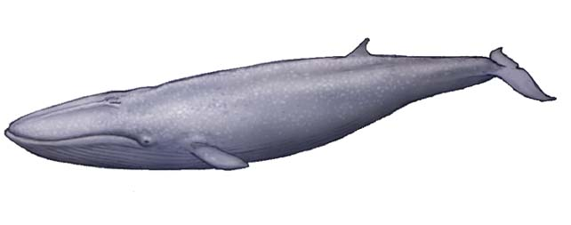 | Ａｎａ  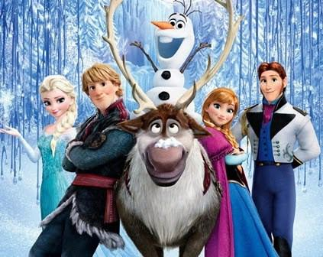 | Ｍａｏ Ａｓａｄａ  
Ｇａｋｕｍｏｎ  ｎｏ Ｓｕｓｕｍｅ  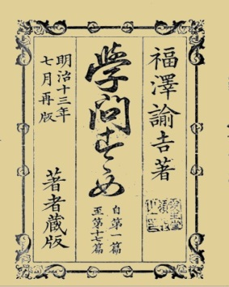 | Ｓａｎｔａ Ｃｌａｕｓ   | Ｇｙｏｚａ  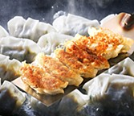 | Ｋｉｉ Ｋｉｔａｎｏ  
Ｉ ｐｈｏｎｅ  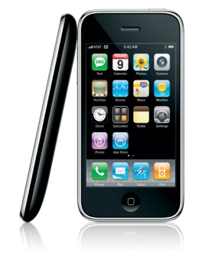 | Ｍａｍｅｈａｃｈｉｄｏｒｉ  （マメハチドリ）  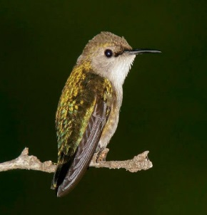 | Ｒａｓｈｏｕｍｏｎ  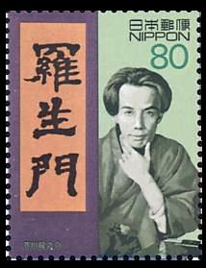 | Ｒｉｏｎ  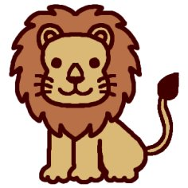
<答えカード裏>
Toyota is the company built by Kiichirou Toyoda.  ・過去分詞 | Yuuto Nagatomo is the man playing soccer in the team, Intel.  ・現在分詞 | Sake is a drink made from rice.  ・過去分詞 | Tetuya Takeda is the man performing Kinpachi-sensei.  ・現在分詞
Tofu is a food made from soybeans.  ・過去分詞 | Blue whale is the largest animal living on the earth.  ・現在分詞 | Ana is the movie watched by  many people all  over the world.  ・過去分詞 | Mao Asada is the woman skating very well.  ・現在分詞
Gakumon no Susume is the book written byYukichi Hukuzawa.  ・過去分詞 | Santa Claus is the man sending presents to children.  ・現在分詞 | Gyoza is a food eaten by many  people in Shizuoka and Tochigi.  ・過去分詞 | Kii Kitano is the woman appearing the TV program, Zip.  ・現在分詞
Iphone is the cellphone made by Apple.  ・過去分詞 | Mamehachidori is the smallest animal living on land.  ・現在分詞 | Rashoumon is the book written by Ryuunosuke Akutagawa.  ・過去分詞 | Rion is the strongest animal living on Savanna.  ・現在分詞

