間接疑問文を理解しよう

○次の文の意味を書きましょう。

Who am I ? 語順…疑問詞+be動詞+主語
( )

I do not who I am. 語順…( )+( )+( )
( )

○わかったことをまとめよう！
・疑問詞（5w1h）を使って疑問文をつくる時、意味は（① ？）となり、語順は( + + )となる。

・間接疑問文では意味は（② ）となり語順は（ + + ）となる。

ＭＥＭＯ

～Who am I?～ 間接疑問
<Rules>
１．じゃんけんをして順番を決めよう。

２．一番初めに勝った人（A）は山札から一枚、カードを引こう。そのカードは他の人に見せてはいけません。

３．残りの３人（B,C,D）でじゃんけんをして、勝った人からワークシートの問いを1から順に聞いていきます。４の情報のヒントはAさんから与えられます。

４．聞いてgetした情報をワークシートに書き入れよう。

５．問いをたずねていって誰のことかわかったら、手を挙げてIs he/she～？と聞こう。答えが当たっていれば、そのカードをgetし、間違っていたら山札にカードを戻そう。

６．一番多くのカードを持っていた人の勝ち！

<ワークシート>
～Who am I?～ 間接疑問
Sample conversation
B: We do not know who he is. Please tell me (1.)where he was born.
A: He was born in Aichi.
C: Tell me (2.)when his birthday is.
A: Its birthday is November 11th.
D: Could you tell me (3.)what his job is?
A: His job is to study English. I also know (4.)what university he entered.
B: Please tell me what university he entered.
A: Nufs.
B or C or D: (わかったら挙手をして)Is he shunsuke Matsui?
A: Yes, it is.→カードをもらう。 / No, he is not.→カードを山札の横に置く。
☆聞き取った情報を下の表に書き入れよう。
 | 1.where he/she was born | 2.when his/her birthday is | 3.what his/her job is | 4.others

<山札カード>
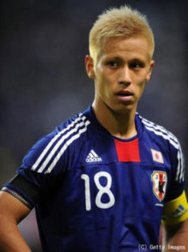 | 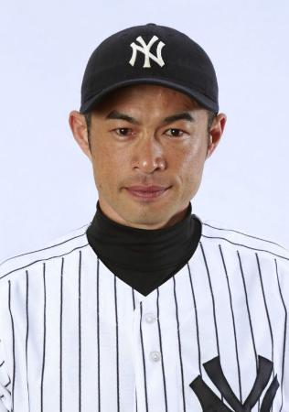 | 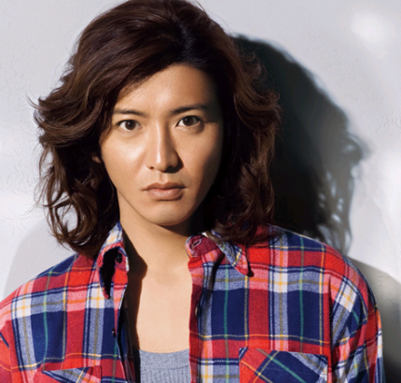 | 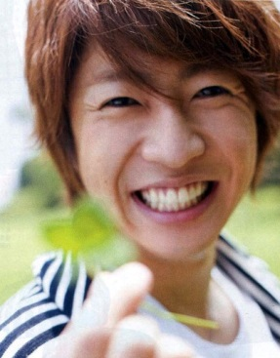
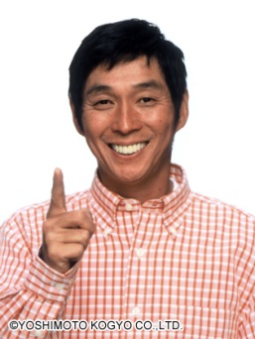 | 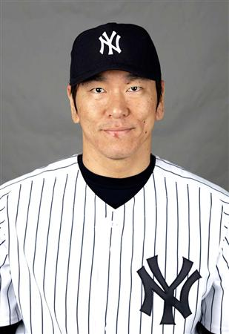 | 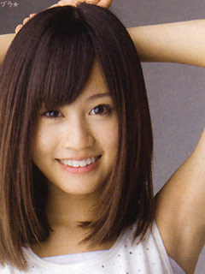 | 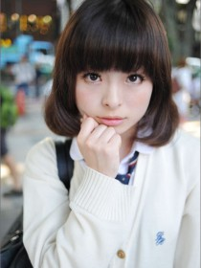
 | 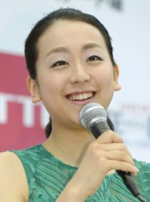 | 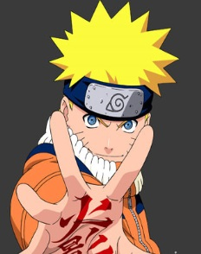 | 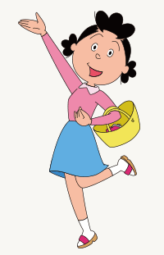
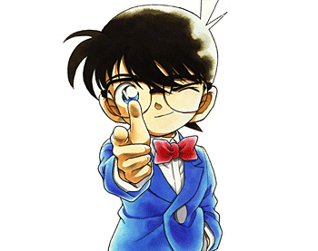 | 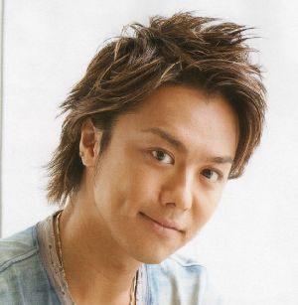 | 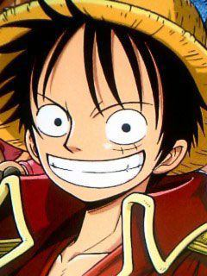 | 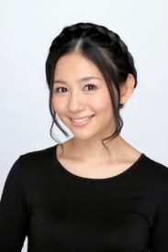
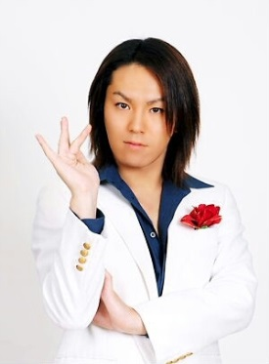 |  | 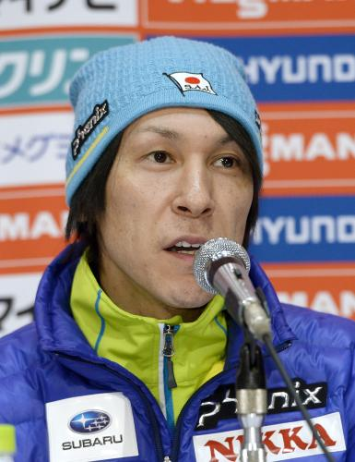 | 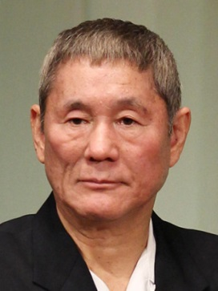

<山札カード裏>
Keisuke Honda  １．Osaka  ２．6/13/1986  ３．Soccer player  ４．what club he belongs to (A.C Miran)  ＊belong:属する | Ichiro  １．Aichi  ２．10/22/1973  ３．Baseball player  ４．what club he belongs to  (Yankees)  ＊belong:属する | Takuya Kimura  １．Tokyo  ２．11/13/1972  ３．Johnny’s  ４．what he is called (Kimutaku) | Masaki Aiba  １．Chiba  ２．12/24/1982  ３．Johnny’s  ４．what TV program he appears (Tensai Shimura Zoo)
Sanma  １．Wakayama  ２．7/1/1955  ３．Entertainer  ４．who his daughter is Imaru) | Hideki Matsui  １．Ishikawa  ２．6/12/1974  ３．Baseball coach  ４．what his uniform number is (55) | Atsuko Maeda  １．Chiba  ２．7/10/1991  ３．Actress and singer  ４．what she was called in AKB  (あっちゃん) | Kyari-  Pamyupamyu  １．Tokyo  ２．1/29/1993  ３．Singer  ４．what her popular song is  (fashion monster)
Doraemon  １．Robot factory  ２．9/3/2112  ３．Helper  ４．who his best friend is (Nobita) | Mao Asada  １．Aichi  ２．9/25/1990  ３．Skater  ４．who her sister is  (Mai Asada) | Naruto  １．Konoha  ２．10/10  ３．Ninja  ４．who the boy likes (Sakura-chan) | Sazae-san  １．Osaka  ２．9/14  ３．Housewife  ４．who her child is (Tara-chan)

Konan  １．Tokyo  ２．5/4  ３．Private detective  ４．who he likes  (Ran Mouri) | Takahiro  １．Yamaguchi  ２．12/8/1984  ３．Singer EXILE  ４．what his part is (vocal) | Luffy  １．Don island  ２．5/5  ３．Pirate  ４．what he can do (arm grows ) | Mari Sekine  １．Tokyo  ２．10/22/1984  ３．Talent  ４．who her father is  (Tsutomu Sekine)
Eikou Kano  １．Miyagi  ２．2/22/1982  ３．Entertainer  ４．what famous phrase he says (Ramen Tukemen Bokuikemen) | Anpanman  １．Bread factory  ２．2/6  ３．Hero  ４．who its rival is (Baikinman) | Noriaki Kasai  １．Hokkaido  ２．6/6/1972  ３．Ski jumper  ４．what he is called (legend) | Takeshi Kitano  １．Tokyo  ２．1/18/1947  ３．Movie maker  ４．what his another name is  (Beat Takeshi)

