26. 関係代名詞～which~

目標：タスクを通して主格の関係代名詞whichを使えるようにする。
対象：中学３年
文法：関係代名詞which
準備：黒板に貼る写真（インプットの時に使用）

○このタスクの進め方
○Pre-Task
例）T: This is an animal. (“牛”の写真を見せながら)
Do you know this animal?
S: Yes, this is a cow.
T: That’s right. A cow gives us milk.
S: So, a cow is an animal which gives us milk.

例）T: This is an animal. (“ペンギン”の写真を見せながら)
Do you know what this animal is?
S: Yes, this is a penguin.
T: That’s right. A penguin cannot fly but can swim well.
S: So, a penguin is an animal which cannot fly but can swim very well.

○Task
- 6人グループを作り、爺抜きを行う。
- じじ抜きカードAとBを、それぞれ別の色の紙に印刷し、Aのカードを３枚、Bのカードを３枚それぞれ配布する。（合計６枚）
- じじ抜きの要領でカードを減らしていく。AとBのカードが一致した場合には、関係代名詞whichを用いて発話する。
- 最終的に手持ちのカードが最初になくなった人の勝ち。
- 最後に６人グループで優勝した人が前に出てきて、クラスで一番のじじ抜きチャンピオンの生徒を決定する。

○ワンポイント・アドバイス
英語が得意でない生徒もいるので、お互いに助けあって発話できるようにしようと促す。

I have a cat.(1)  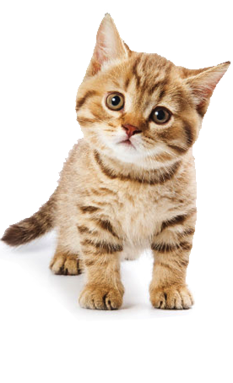 |  | This is the cake.(2)  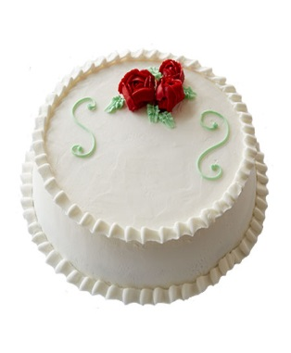 | This is a car.(3)  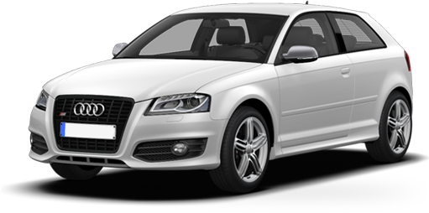
This is an animal.(4)  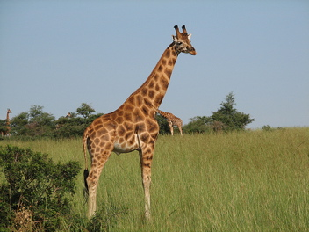 |  | I like a CD.(5)  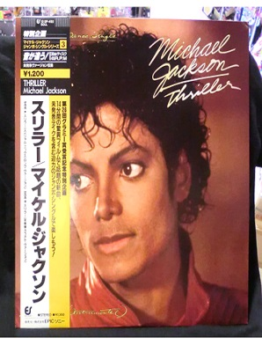 | I like a book.(6)  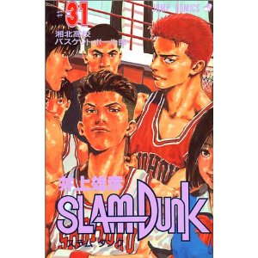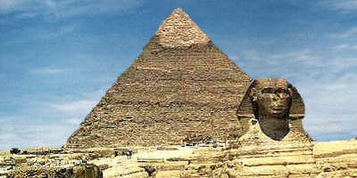
That is a bus.(7)  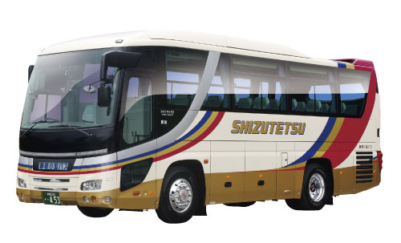 |  | He has a jacket.(8)  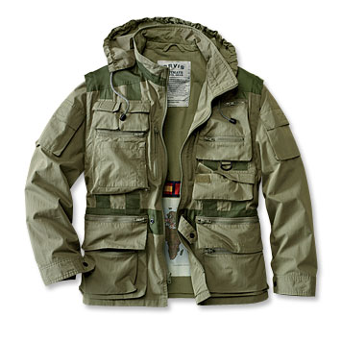 | This is an old building.(9)
This is the camera.(10)


It has blue eyes.(1) | It was made by Emi.(2) | It was made in Japan. (3)
This animal has a long neck.(4) | This CD is very famous all over the world.(5) | The book is very funny.(6)
It goes to Shinjuku Station.(7) | It has many pockets.(8) | The building was built by the kings of Egypt.(9)

Kana has a dog.(11)  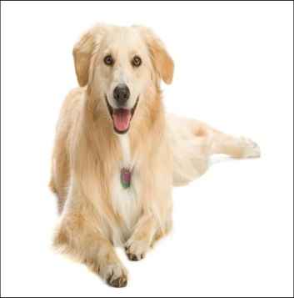 | I live in a house.(12)  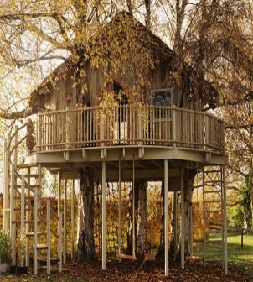 | Soccer is a sport.(13)  
  This is a movie.(14) | Ken has a watch.(15)  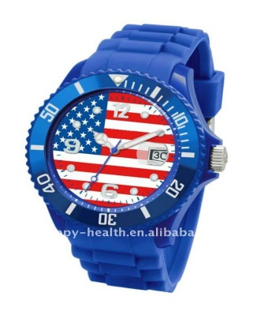 | I am reading a book.(16)  
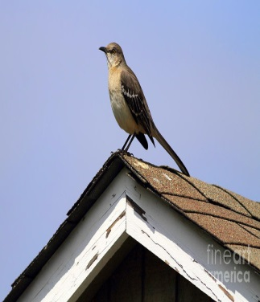  Can you see the bird?.(17) | This is the plane.(18)   | 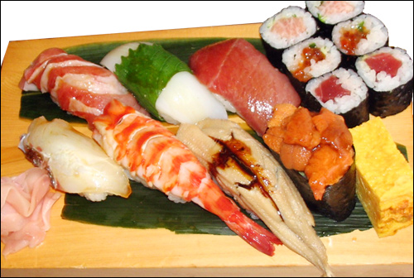  Jim likes sushi.(19)

It is called Hana.(11) | It has a big tree.(112) | It is played in many countries. (13)
It makes us happy.(14) | It is made in America.(15) | It has more than two thousand pages.(16)
It is on the roof of your house.(17) | It is going to arrive in Tokyo at six.(18) | It is popular in Japan.(19)

