This apple is as big as that one.
Class no. name:
Step1 先生の話を聞いて、物の大きさ比べをしよう！
物 | 大きさは？
Duffy vs. Shelly May
Apple vs. pear
Japan vs. Germany

Step2 もう一度聞いて、( )の中を埋めよう！
- Duffy is ( ) tall ( ) Shelly May.
- This apple is ( ) big ( ) that pear.
- Japan is ( ) large ( ) Germany.

Step3 Today’s Point!
Duffy is ( ) tall ( ) Shelly May.
( )には、( )という意味がある。( )の間に入る形容詞・副詞は（ ）。

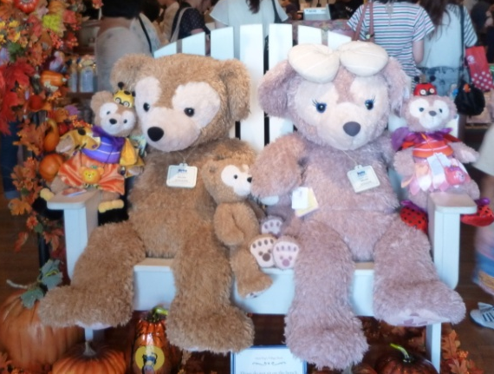
Which is bigger, Duffy or Shelly May?

