 | 
 | 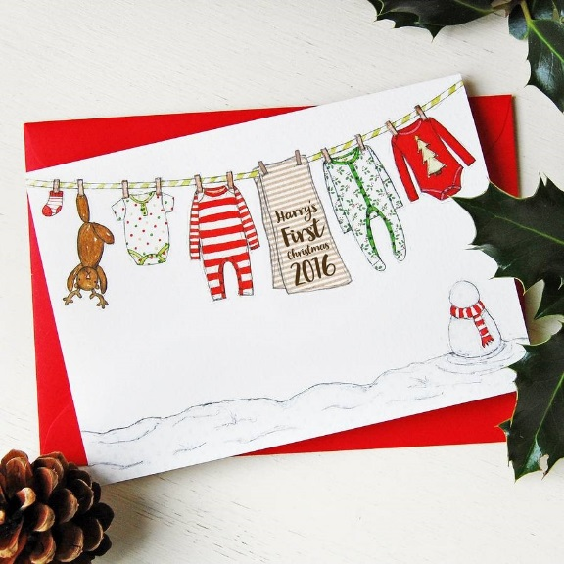
 | 

 | 
 | 
 | 

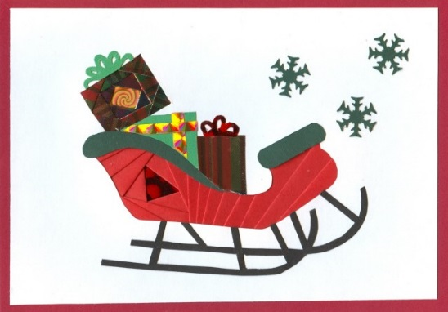 | 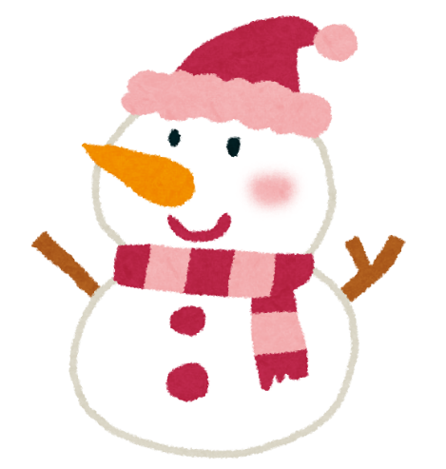
 | 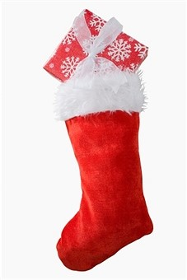

bell | candle
stocking | Christmas tree
snowman | decoration

star | present
chimney | reindeer
sleigh | Santa Claus

card | ginger bread man
candy cane | Merry Christmas

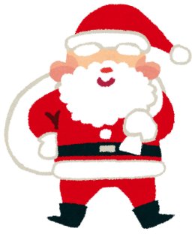
Word Search
Name
○でかこもう！
c | a | n | d | l | e | a | b | s | h | h | u | e | w | c
t | n | r | e | i | n | d | e | e | r | k | u | e | r | h
j | g | h | c | s | a | n | t | a | c | l | a | u | s | r
f | b | p | o | c | a | n | d | y | c | a | n | e | v | i
m | e | r | r | y | c | h | r | i | s | t | m | a | s | s
v | l | e | a | b | h | a | n | m | n | t | d | o | l | t
d | l | s | t | l | i | k | r | j | o | p | a | r | e | m
j | p | e | i | p | m | i | s | d | w | b | q | r | i | a
k | q | n | o | r | n | l | i | u | m | b | l | c | g | s
z | w | t | n | r | e | p | p | o | a | a | k | x | h | t
x | j | f | o | c | y | y | t | o | n | f | u | z | r | r
g | i | n | g | e | r | b | r | e | a | d | m | a | n | e
s | a | s | t | o | c | k | i | n | g  word list  bell present gingerbread man  candle reindeer Santa Claus  Christmas tree star decoration  chimney stocking merry Christmas  card sleigh candy cane snowman | u | t | y | u | e

