Ａｉｒｐｏｒｔ ｏｆｆｉｃｅｒ Ｂｉngo！
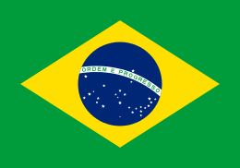  Brazil  Name  How long  Purpose: |   Canada  Name  How long  Purpose: |   Australia  Name  How long  Purpose:
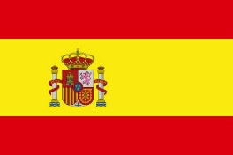  Spain  Name  How long  Purpose: | 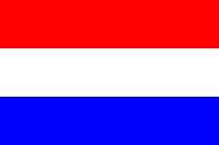  France  Name  How long  Purpose: | 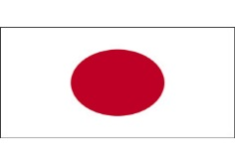  Japan  Name  How long  Purpose:
  Korea  Name  How long  Purpose: |   America  Name  How long  Purpose: |   Italy  Name  How long  Purpose:
Conversation at セントレア空港！
Officer: Show me your passport please?
Tourist: Sure
Officer: What is your name?
Tourist: I am
Officer: How long are you going to stay in Japan?
Tourist: I’m going to stay in Japan for
Officer: What’s the purpose of your visit?
Tourist: For
Officer: Have a nice trip!

aｉｒｐｏｒｔ ｏｆｆｉｃｅｒ Ｂｉngo！
Brazil  Name  How long  Purpose: | Canada  Name  How long  Purpose: | 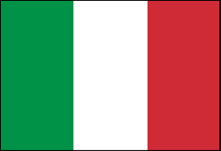  Australia  Name  How long  Purpose:
Spain  Name  How long  Purpose: | France  Name  How long  Purpose: | Japan  Name  How long  Purpose:
Korea  Name  How long  Purpose: | America  Name  How long  Purpose: | Italy  Name  How long  Purpose:
Conversation at セントレア空港！
Officer: Show me your passport please?
Tourist: Sure
Officer: What is your name?
Tourist: I am
Officer: How long are you going to stay in Japan?
Tourist: I’m going to stay in Japan for
Officer: What’s the purpose of your visit?
Tourist: For
Officer: Have a nice trip!

aｉｒｐｏｒｔ ｏｆｆｉｃｅｒ Ｂｉngo！
Brazil  Name  How long  Purpose: | Spain  Name  How long  Purpose: | Australia  Name  How long  Purpose:
Canada  Name  How long  Purpose: | 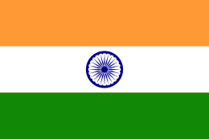  India  Name  How long  Purpose: | Korea  Name  How long  Purpose:
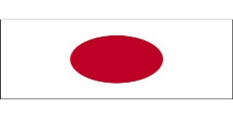  Japan  Name  How long  Purpose: | Italy  Name  How long  Purpose: | America  Name  How long  Purpose:
Conversation at セントレア空港！
Officer: Show me your passport please?
Tourist: Sure
Officer: What is your name?
Tourist: I am
Officer: How long are you going to stay in Japan?
Tourist: I’m going to stay in Japan for
Officer: What’s the purpose of your visit?
Tourist: For
Officer: Have a nice trip!

aｉｒｐｏｒｔ ｏｆｆｉｃｅｒ Ｂｉngo！
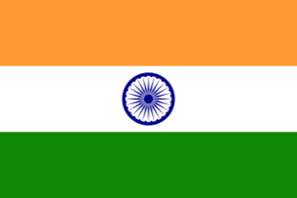  India  Name  How long  Purpose: | Japan  Name  How long  Purpose: | Australia  Name  How long  Purpose:
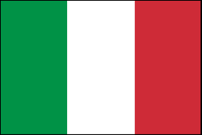  Italy  Name  How long  Purpose: | France  Name  How long  Purpose: | Canada  Name  How long  Purpose:
Korea  Name  How long  Purpose: | America  Name  How long  Purpose: | Spain  Name  How long  Purpose:
Conversation at セントレア空港！
Officer: Show me your passport please?
Tourist: Sure
Officer: What is your name?
Tourist: I am
Officer: How long are you going to stay in Japan?
Tourist: I’m going to stay in Japan for
Officer: What’s the purpose of your visit?
Tourist: For
Officer: Have a nice trip!

aｉｒｐｏｒｔ ｏｆｆｉｃｅｒ Ｂｉngo！
Korea  Name  How long  Purpose: | Canada  Name  How long  Purpose: | India  Name  How long  Purpose:
Spain  Name  How long  Purpose: | France  Name  How long  Purpose: | America  Name  How long  Purpose:
Brazil  Name  How long  Purpose: | Japan  Name  How long  Purpose: | Italy  Name  How long  Purpose:
Conversation at セントレア空港！
Officer: Show me your passport please?
Tourist: Sure
Officer: What is your name?
Tourist: I am
Officer: How long are you going to stay in Japan?
Tourist: I’m going to stay in Japan for
Officer: What’s the purpose of your visit?
Tourist: For
Officer: Have a nice trip!
aｉｒｐｏｒｔ ｏｆｆｉｃｅｒ Ｂｉngo！
Brazil  Name  How long  Purpose: | Italy  Name  How long  Purpose: | Australia  Name  How long  Purpose:
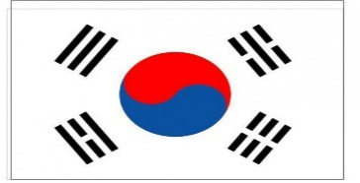  Korea  Name  How long  Purpose: | France  Name  How long  Purpose: | 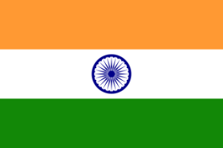  India  Name  How long  Purpose:
Spain  Name  How long  Purpose: | America  Name  How long  Purpose: | Canada  Name  How long  Purpose:
Conversation at セントレア空港！
Officer: Show me your passport please?
Tourist: Sure
Officer: What is your name?
Tourist: I am
Officer: How long are you going to stay in Japan?
Tourist: I’m going to stay in Japan for
Officer: What’s the purpose of your visit?
Tourist: For
Officer: Have a nice trip!

aｉｒｐｏｒｔ ｏｆｆｉｃｅｒ Ｂｉngo！
Australia  Name  How long  Purpose: | Canada  Name  How long  Purpose: | Brazil  Name  How long  Purpose:
Spain  Name  How long  Purpose: | Italy  Name  How long  Purpose: | Japan  Name  How long  Purpose:
Korea  Name  How long  Purpose: | 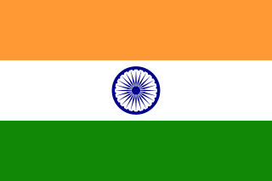  India  Name  How long  Purpose: | France  Name  How long  Purpose:
Conversation at セントレア空港！
Officer: Show me your passport please?
Tourist: Sure
Officer: What is your name?
Tourist: I am
Officer: How long are you going to stay in Japan?
Tourist: I’m going to stay in Japan for
Officer: What’s the purpose of your visit?
Tourist: For
Officer: Have a nice trip!

aｉｒｐｏｒｔ ｏｆｆｉｃｅｒ Ｂｉngo！
Spain  Name  How long  Purpose: | 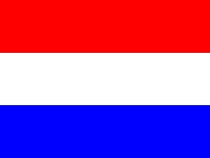  France  Name  How long  Purpose: | Australia  Name  How long  Purpose:
Brazil  Name  How long  Purpose: | Canada  Name  How long  Purpose: | America  Name  How long  Purpose:
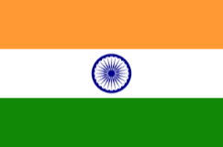  India  Name  How long  Purpose: | 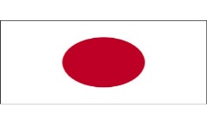  Japan  Name  How long  Purpose: | Italy  Name  How long  Purpose:
Conversation at セントレア空港！
Officer: Show me your passport please?
Tourist: Sure
Officer: What is your name?
Tourist: I am
Officer: How long are you going to stay in Japan?
Tourist: I’m going to stay in Japan for
Officer: What’s the purpose of your visit?
Tourist: For
Officer: Have a nice trip!

aｉｒｐｏｒｔ ｏｆｆｉｃｅｒ Ｂｉngo！
Brazil  Name  How long  Purpose: |   Italy  Name  How long  Purpose: | 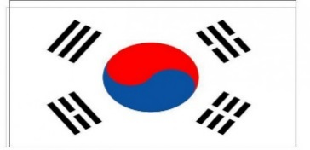  Korea  Name  How long  Purpose:
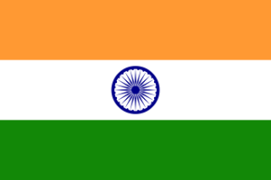  India  Name  How long  Purpose: | Japan  Name  How long  Purpose: | 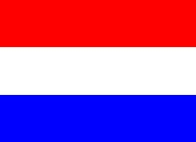  France  Name  How long  Purpose:
Australia  Name  How long  Purpose: | America  Name  How long  Purpose: | Canada  Name  How long  Purpose:
Conversation at セントレア空港！
Officer: Show me your passport please?
Tourist: Sure
Officer: What is your name?
Tourist: I am
Officer: How long are you going to stay in Japan?
Tourist: I’m going to stay in Japan for
Officer: What’s the purpose of your visit?
Tourist: For
Officer: Have a nice trip!

aｉｒｐｏｒｔ ｏｆｆｉｃｅｒ Ｂｉngo！
America  Name  How long  Purpose: | India  Name  How long  Purpose: | 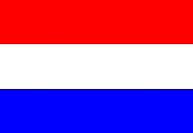  France  Name  How long  Purpose:
Spain  Name  How long  Purpose: | Australia  Name  How long  Purpose: | Japan  Name  How long  Purpose:
Italy  Name  How long  Purpose: | 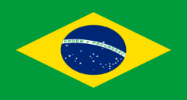  Brazil  Name  How long  Purpose: | Korea  Name  How long  Purpose:
Conversation at セントレア空港！
Officer: Show me your passport please?
Tourist: Sure
Officer: What is your name?
Tourist: I am
Officer: How long are you going to stay in Japan?
Tourist: I’m going to stay in Japan for
Officer: What’s the purpose of your visit?
Tourist: For
Officer: Have a nice trip!

aｉｒｐｏｒｔ ｏｆｆｉｃｅｒ Ｂｉngo！
Canada  Name  How long  Purpose: | Brazil  Name  How long  Purpose: | Spain  Name  How long  Purpose:
Australia  Name  How long  Purpose: | France  Name  How long  Purpose: | Japan  Name  How long  Purpose:
America  Name  How long  Purpose: | Korea  Name  How long  Purpose: | 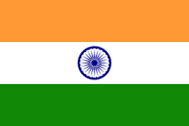  India  Name  How long  Purpose:
Conversation at セントレア空港！
Officer: Show me your passport please?
Tourist: Sure
Officer: What is your name?
Tourist: I am
Officer: How long are you going to stay in Japan?
Tourist: I’m going to stay in Japan for
Officer: What’s the purpose of your visit?
Tourist: For
Officer: Have a nice trip!

