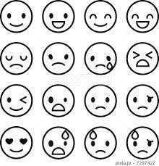
sad
happy
angry
tired
bored
shocked
excited
afraid

I lost my wallet.
I got a present on my birthday.
My sister broke my toys.

I ran from my house to school.
I watched a boring movie.
I got fat.
I dated with my lover.
I saw some ghosts (お化け).

