What’s new with you?
最近何があった？


<Step 1> 以下の文を読んで絵と合う語を選ぼう！
I lost my wallet. There were 10,000 yen. It is not found still now. I’m ( excited / sad ). So, losing my wallet makes me ( excited / sad ).
What’s new with you?
What’s new with you?
Yesterday was my birthday! My friends gave me a present!
I was ( happy / sad ). So, it made me ( happy / sad).

(1)
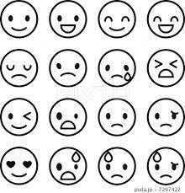

(2)

(3)
I got up late this morning, so I ran to school. Now,
I’m ( tired / hungry ). Running made me ( tired / hungry).
What’s new with you?


(4)
I didn’t do my homework. My teacher got very ( cute / angry ). So, I made my teacher ( cute / angry ).
What’s new with you?

<Step 2> Grammar Point

Losing my wallet makes me sad.
(意味： )

make + 名詞 + 形容詞 → (意味： )

<Step 3> Matching Game!
○ルール○
グループで競争です！
より多くのcardをgetしよう！

<Dialog>
全員: What’s new with you?
A: I lost my umbrella.(カードを読む)
全員: How did you feel?
～2つの絵が同じ場合～  A: I was sad, so it made me sad.  全員: That’s too bad. / That sounds nice.  Cardをgetし、続ける。 | ～2つの絵が異なる場合～  A: I was happy, but it didn’t make me happy.  全員: Okay. / Uh-huh.  Cardを戻し、次の人に交代する。

