I was happy to hear that.
Class( ) No.( ) Name( )

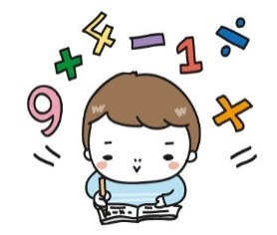
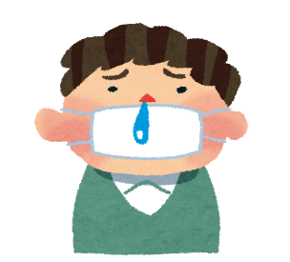
<Step1> 当てはまる方に○をつけよう！
②
Our science teacher is absent this week
because he ( had / didn’t have ) a cold.
He can’t do anything. So, I am sorry to hear that.
①
We had term tests last week.
Our math teacher said “Students in your class
( did / didn’t do ) a very good job on the math test!” to me.
I was happy to hear that.

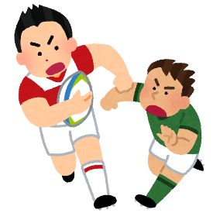

③
There was a rugby game in Aichi.
When I was at Nagoya Station,
I ( met / didn’t meet ) Ayumu Goromaru.
So, I was surprised to see him,

<Step2> まとめ

・I was happy to hear that. (訳 )
・主語 + be動詞 + ( ) + to + 動詞の原形 ～.
→ ( ) という意味になり( )を表す。

<Step3> BINGO!

Meet an entertainer  (芸能人)  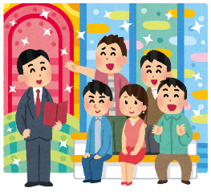  ( )  Name:( ) | 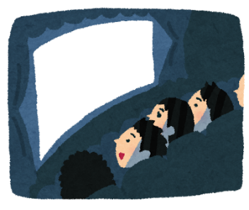  Watch movies  ( )  Name:( ) |   Read books  ( )  Name:( )
  Play soccer  ( )  Name:( ) | Sleep a lot  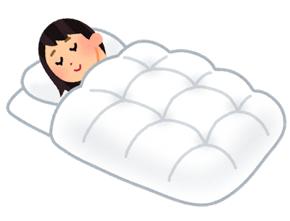  ( )  Name:( ) | 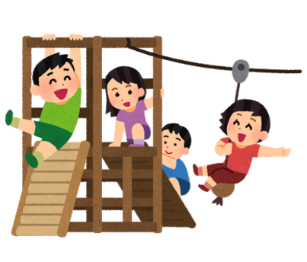  Play with friends  ( )  Name:( )
Do homework    ( )  Name:( ) | Lose your wallet    (財布)  ( )  Name:( ) | Study English  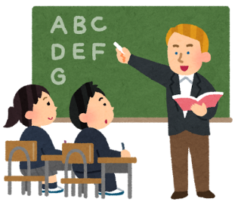  ( )  Name:( )

<形容詞>
・happy ・sad ・surprised ・excited ・bored(つまらない)

Model Dialog:
(じゃんけん)
A(winner): How do you feel when you ?
B:(loser): I’m to .

(同じ場合)
A: Really? Me, too! I’m to . Please write your name.
B: Ok, here you are! How about you? How do you feel when you ?
A: I’m to .
B: Really? Me, too! I’m to . Please write your name.
A: Thank you! See you.
B: See you!

(違う場合)
A: Ok, thank you.
B: You’re welcome! How about you? How do you feel when you ?

<Step4> Let’s write!

