クイズ大会
Class( ) No.( ) Name( )

<Step1> Let’s think!

①
is an actress. (女優)
She appeared on TV at 9 p.m. on Monday from September to December.
So, is the actress who appeared on TV at 9 p.m. on Monday from October to December.
Who is she?
She is.

②

is a rugby player.
He is famous for the pose of the routine.
So, is the rugby player who is famous for the pose of the routine.

Who is he?
He is .

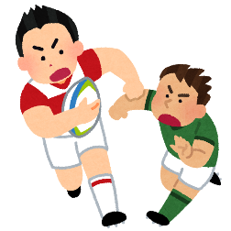


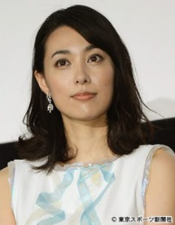

③

is a singer.
He married Kazue Fukiishi.
So, is the singer who married Kazue Fukiishi.

Who is he?
He is .

④

is a singer.
She is a captain of AKB48.
So, is the singer who is the captain of AKB48.

Who is she?
She is .
<Step2> まとめ
・Masaharu Fukuyama is a singer. + He married Kazue Fukiishi.
(訳. ) (訳. )
→ Masaharu Fukuyama is the singer who married Kazue Fukiishi.
(訳. )
・ “ who ” は ( ) を詳しく説明している。
・この “ who ” のことを ( ) という。

<Step3> クイズ大会！
(じゃんけん)
A(winner): Hello. Who is he/she?
This is the man/woman ①who . Who is he/she?
B(loser): He/She is . Right?

(正解の場合)
A: Yes, that’s right!
B: Oh, really? So, next is my turn. Who is he/she?
This is the man/woman ①who . Who is he/she?
A: He/She is . Right?
B: Yes, that’s right!

(不正解の場合)
A: No…
B: Oh, really? So, please give me the next hint.
A: OK. This is the man/woman ②/③who . Who is he/she?
B: He/She is . Right?

<Your hints>
This is the man/woman ① .

② .

③ .

①  3points | ①＋②  2points | ①＋②＋③  1points
計



