あの人の特技はな～んだ？
Step1 絵を見て表を埋めよう！
 | 予想 | 答え
Doraemon |  | Yes / No
Shizuka |  | Yes / No
Suneo’s house |  | Yes / No
Gian and Suneo |  | Yes / No
Step2 話を聞いて、聞こえたほうに○をつけよう！
- ( Does / Do) Doraemon ( play / plays ) baseball? → Yes, he do. / Yes, he does.
- ( Do / Does ) Shizuka ( likes / like ) violin? → No, she doesn’t. / No, she don’t.
- ( Does / Do ) Suneo’s house ( have / has ) a pool? → No, it don’t. / No, it doesn’t.
- ( Do / Does ) Gian and Suneo ( lives / live ) in Tokyo?
→ Yes, they do. / Yes, they doesn’t.
Step3 気づいたことをまとめよう！
- Does Suneo’s house have a pool? (意味: )
Yes, it does. / No, it doesn’t.
(意味 ) (意味 )
- Does he/she play baseball? (意味 )
Yes, ( ) does. / No, ( ) doesn’t.
(意味 ) (意味 )
- Do Gian and Suneo live in Tokyo?
なんでDo なの？？→( )だからDoになる！
- Suneo’s house has a pool. (意味: )
( )の複数形！
この場合のHasの意味は( )だよ！

Step4 あの人の特技はな～んだ？？
語群 スポーツ  soccer basketball baseball softball | 語群 楽器  the trombone, the guitar, ,the piano, the drums
会話例
Hello! (じゃんけん。勝ち→A, 負け→B)
A: I have ○○’s card.
B: Really? Does he/she play △△?
A: Yes, he/she does. / No, he/she doesn’t.
B: Oh, I see. Thank you!
AとB交代
Nice talking with you!
ビンゴをできるだけたくさん完成させよう！
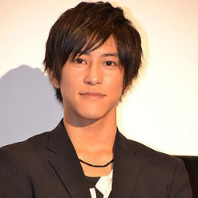  Sano Gaku  soccer | 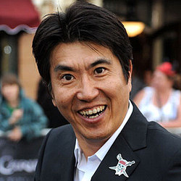  Ishibashi Takaaki  baseball |   Nakama Yukie  the trombone
  Darenogare Akemi  softball | Free |   Horikita Maki  basketball
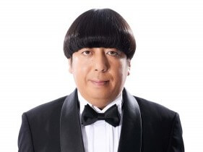  Himura Yuuki  the piano |   Kashiwagi Yuki  the drums |   Kusanagi Tsuyoshi  the guitar

Step5 自分が質問した表現とその答えを5つ書いてみよう！
例 Does he play soccer? Yes, he does. / No, he doesn’t.

