Class ( ) Name ( )
広告を作ろう！！

<STEP1> （ ）に当てはまるメニューを書こう！！
Yoshi’s Burger

Hセット
・teriyaki burger
・fries (M)
・sprite
550 yen
Cセット
・rice burger
・chocolate pie
・coffee
470 yen
Dセット
・cheese burger
・fries (M)
・orange juice
540 yen

Gセット
・bacon burger
・chocolate pie
・coffee
480 yen
Fセット
・cheese burger
・fries (L)
・coke
570 yen
Eセット
・teriyaki burger
・fries (M)
・apple juice
540 yen
Bセット
・bacon burger
・fries (M)
・coke
530 yen
Aセット
・fish burger
・fries (M)
・orange juice
550 yen

Taro
I want to eat fries (M) and fish burger.
Jun
I want to drink sprite.

I want to eat bacon burger and chocolate pie.


Hanako

I want to eat cheese burger and fries (M).

Kana
Question

Taro wants to choose ( ) that has fish burger, fries (M) and orange juice.
Jun wants to choose ( ) that has teriyaki burger, fries (M) and sprite.
Hanako wants to choose ( ) that has bacon burger, chocolate pie and coffee.
Kana wants to choose ( ) that has cheese burger, fries (M) and orange juice.

<STEP2> 今日のポイント！！
前回の復習
Becky is the student.
She comes from Canada.
↓
Becky is the student who comes from Canada.
訳：（ ）

This is Aセット.
It has fish burger, fries (M) and orange juice.
→ This is Aセットthat has fish burger, fries (M) and orange juice.
訳：（ ）

that以降の文 は Aセット を ( ) している。
whoと同じ使い方。But…
thatを使うときは先行詞が（ ）のとき。

＊thatはwhichでもOK。同じ役目を果たしている。

今がお買い得！！！！！！

_________ yen
＿＿＿＿＿ yen

_________ yen
__________ yen
_________ yen

__________ yen
_________ yen

_________ yen
__________ yen

_________ yen
__________ yen

今がお買い得！！！！！！
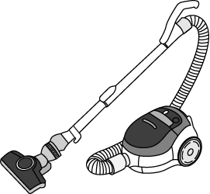 | This is a vacuum cleaner. It can suck up the trash. (suck up: 吸い取る)
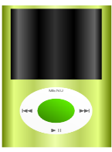 | This is an ipod.  It can save many songs.
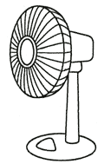 | This is an electric fan.  It can feed wind.  (feed:～を送る)
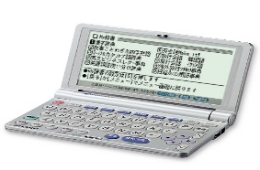 | This is an electronic dictionary.  It has many kinds of dictionaries
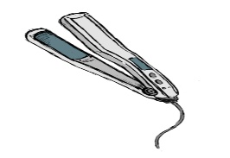 | This is a hair iron.  It can make hair straight.
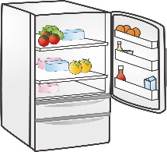 | This is a refrigerator.  It can keep foods fresh.
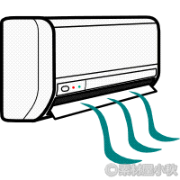 | This is an air conditioner.  It keeps a room cool.
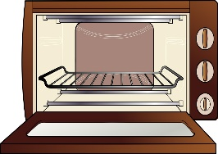 | This is an oven.  It can bake some foods with a high temperature.
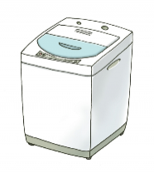 | This is a washing machine.  It can wash clothes.
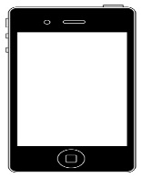 | This is an iphone.  It can access the Internet quickly.

_________ yen
＿＿＿＿＿ yen

_________ yen
__________ yen
_________ yen

_________ yen
__________ yen

_________ yen
__________ yen

__________ yen
_________ yen

