
Number＿＿＿＿＿＿＿ Name ＿＿＿＿＿＿＿＿＿
Show me your …

Step1) 先生がお願いしたことは何？

○○さんに | お願いしたこと

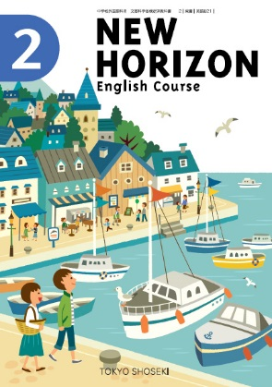
Step2) 会話を聞いてカッコの中を埋めよう！
- Did you finish writing your name?
Show me ( ) handout, please.
- I didn’t have my textbook today.
Please show ( ) your textbook.
- Your pencil case is so nice!
( ) ( ) your pencil case, please.

Step3) Today’s point!!!
- ～③には日本語、④には英語を入れて意味を考えてみよう！

★Show me your handout, please.
(訳: )
★Show のあとに、(① )＋(② ) を表す語を入れると、「(① )に(② ) を(③ ) 」という意味になる。
★誰かにお願いする場合には、文の先頭または文末に(④ ）をつけること。

  America  ・Name: ( )  ・How long are you going to stay?  (3 years/ 2 weeks/ 5 days)  ・Purpose; (sightseeing/ work/ study) |   Canada  ・Name: ( )  ・How long are you going to stay?  (3 years/ 2 weeks/ 5 days)  ・Purpose; (sightseeing/ work/ study)
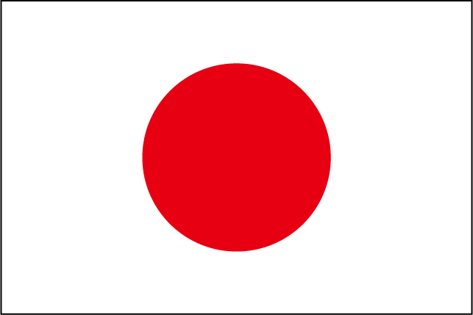  Japan  ・Name: ( )  ・How long are you going to stay?  (4 years/ 5weeks/ 6days)  ・Purpose; (sightseeing/ work/ study) |   France  ・Name: ( )  ・How long are you going to stay?  (4 years/ 5weeks/ 6days)  ・Purpose; (sightseeing/ work/ study)
  Australia  ・Name: ( )  ・How long are you going to stay?  (5 years/ 6weeks/ 4days)  ・Purpose; (sightseeing/ work/ study) |   Mexico  ・Name: ( )  ・How long are you going to stay?  (5 years/ 6weeks/ 5days)  ・Purpose; (sightseeing/ work/ study)
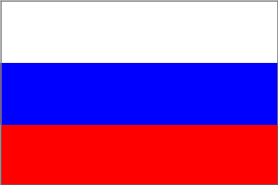  Russia  ・Name: ( )  ・How long are you going to stay?  (3 years/ 5weeks/ 6days)  ・Purpose; (sightseeing/ work/ study) |   Korea  ・Name: ( )  ・How long are you going to stay?  (3 years/ 5weeks/ 6days)  ・Purpose; (sightseeing/ work/ study)
  Italy  ・Name: ( )  ・How long are you going to stay?  (4 years/ 5weeks/ 6days)  ・Purpose; (sightseeing/ work/ study) |   Vietnam  ・Name: ( )  ・How long are you going to stay?  (4 years/ 5weeks/ 6days)  ・Purpose; (sightseeing/ work/ study)














