どうして○○？
class ( ) name ( )

Step1 先生の英語を聞いて表を埋めてみよう！

先生が見せてくれたものは？ | そのもので何がしたいの？

Step2 もう一度先生の英語を聞いて聞こえた単語に〇をつけよう！
- This is a watermelon.
I have a watermelon ( if / when / because ) I want to do スイカ割り.

- This is a camera.
I have a camera ( when / because / if ) I want to take pictures.

- This is a 虫よけスプレー.
I have a 虫よけスプレー ( because / if / when ) I want to run away from mosquitoes. ※mosquito : 蚊

Step3 分かったことをまとめよう！
I have a watermelon because I want to do スイカ割り.
→・I have a watermelon. 訳 ( )
・I want to do スイカ割り. 訳 ( )

Becauseはどんな意味になるだろう、、、 ( )

I have a watermelon because I want to do スイカ割り.
訳 ( )
becauseはふたつの文をひとつの文に ( ) 働きをする。

Step4 マッチングゲーム！
- 読み手は読み札から一枚とる。
- AとBの2文を読む。
- その文から連想される絵カードを選ぶ。
- 絵カードを選んだ人はbecauseを使ってAとBをつなげて読む。
例：A because B.
- 裏向けてその文が正しければカードをゲット！！

Step5 つなげた文を書いてみよう！


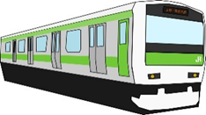

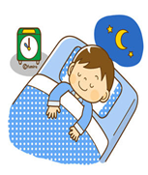

A : He slept a lot yesterday.  B : He was sick. | 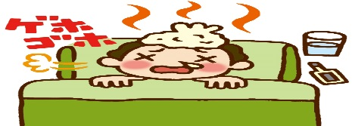  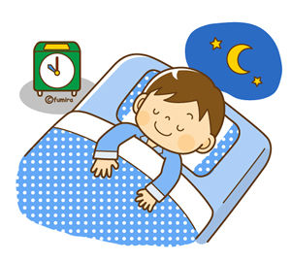  ・・・
A : My mother didn’t cook dinner last night.  B : She was sick. | 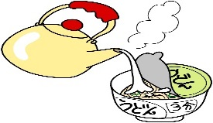    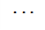
A : I was absent yesterday.  B : I had fever. | 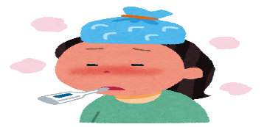  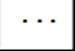  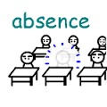
A : I went home late yesterday.  B : The train stopped. | 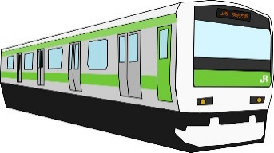    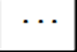  
A : I have an umbrella.  B : It is rainy. |     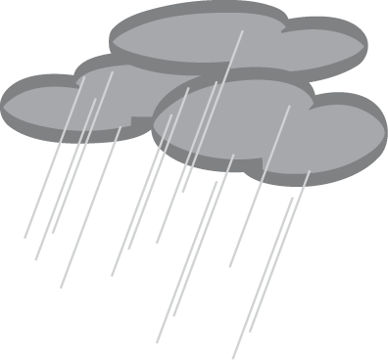

A : I go to the library.  B : I want to read books. |     
A : There was no game.  B : It was rainy. |     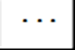  
A : I can’t buy many things.  B : I don’t have a lot of money. |     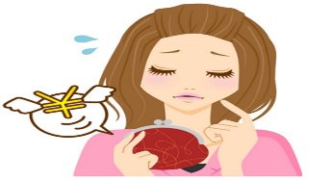  
A : I am happy.  B : I got a lot of money. |   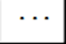  
A : I have a stomachache.  B : I ate much ice cream. | 