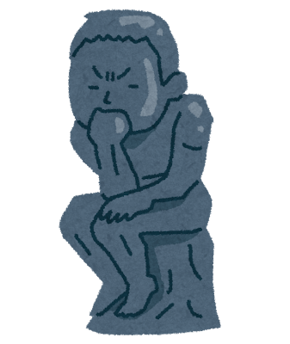
だれのことかな？？

Step1 二人の会話を読んで表に情報をうめよう！！

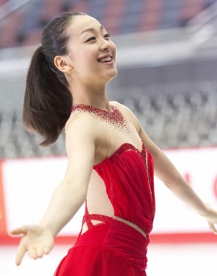
①名前 浅田 真央
住んでいる所
誕生日
好きなもの

M : Mika
K : Ken
M : Hi, Ken. Where does Mao Asada live?
K : She lives in Aichi.
M : I see. I’ll ask you again. Do you know where she lives?
K : Yes, I do. She lives in Aichi.
M : Next, when was she born?
K : She was born on September 25 in 1990.
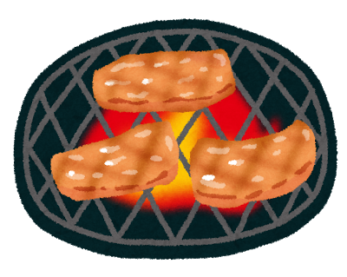
M : Ok. I’ll ask you again. Do you know when she was born?
K : Yes, I do. She was born on September 25 in 1990.
M : Last, what does she like?
K : She likes “Yakiniku”.
M : I see. I’ll ask you again. Do you know what she likes?
K : Yes, I do. She likes “Yakiniku”.


②名前 二宮 和也
住んでいる所
誕生日
好きなもの

K : Hi, Mika. Where does Kazunari Ninomiya live?
M : He lives in Tokyo.
K : I see. I’ll ask you again. Do you know where he lives?
M : Yes, I do. He lives in Tokyo.
K : Next, when was he born?
M : He was born on June 17 in 1983.
K : Ok. I’ll ask you again. Do you know when he was born?
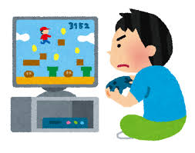
M : Yes, I do. He was born on June 17 in 1983.
K : Last, what does he like?
M : He likes playing video game.
K : I see. I’ll ask you again. Do you know what he likes?
M : Yes, I do. He likes playing video games.

Step2 正しい方に○をつけよう！！
- I know ( what / when / where ) Mao Asada lives. She lives in Aichi.
② I know ( what / when / where ) she was born. She was born on September 25 in 1990.
③ I know ( what / which / when ) she likes. She likes “Yakiniku”.

Step3 今日のまとめ！！
復習 Where does she live?
☆ I know where she lives.
訳（ ）
☆語順は 疑問詞＋（ ）＋（ ）



Step4 だれのことか当てよう！！

<Model dialog>
A : I have a boy’s / a girl’s information.
B : Please tell me when he / she was born.
A : He / She was born on .
B : Please tell me where he / she lives.
A : He / She lives in .
B : Please tell me what food he / she likes.
A : He / She likes . Do you know who he / she is?
↓
Yes の場合
B : Yes, I do. He / She is name.
A : That’s right.

No の場合
B : I don’t know who he / she is.
So, please tell me what he / she does after school.
A: He / She belongs to .
B : Please tell me what his / her hobby is.
A : His / Her hobby is .

＜ルール＞
☆じゃんけんで順番を決める ☆三回までまちがえてよい
☆５～７回ペアを変える

＜得点＞
３点（ヒント３つ） | ２点（ヒント４つ） | 1点（ヒント５つ）
☆０点・・・３回以上間違えた

名前  ①誕生日  ②住んでいる所  ③すきな食べ物  ④部活  ⑤趣味 | 名前  ①誕生日  ②住んでいる所  ③すきな食べ物  ④部活  ⑤趣味 | 名前  ①誕生日  ②住んでいる所  ③すきな食べ物  ④部活  ⑤趣味
名前  ①誕生日  ②住んでいる所  ③すきな食べ物  ④部活  ⑤趣味 | 名前  ①誕生日  ②住んでいる所  ③すきな食べ物  ④部活  ⑤趣味 | 名前  ①誕生日  ②住んでいる所  ③すきな食べ物  ④部活  ⑤趣味
名前  ①誕生日  ②住んでいる所  ③すきな食べ物  ④部活  ⑤趣味 | 名前  ①誕生日  ②住んでいる所  ③すきな食べ物  ④部活  ⑤趣味 | 名前  ①誕生日  ②住んでいる所  ③すきな食べ物  ④部活  ⑤趣味

