世界の建造物

STEP1 話を聞いてマッチングしよう


Ron Harry Draco
。 。 。




。 。 。

Neville Tom Hermione

STEP2 聞こえた方に⚪︎をつけよう

1. Harry casts a spell ( as / is ) well as Tom. *cast a spell-呪文を唱える

2. Ron is ( as / is ) old as Neville.

3. Draco isn't ( as / so ) honest as Hermione.

STEP3 Noticing 黒枠の中を埋めよう
同等比較 ( ) + A(形容詞) + ( ) + B で

B と同じくらい A だ。 という文になる。

例) He is as tall as I. 和訳 （ ）
She isn't as beautiful as me. 和訳 （ ）

＊
STEP4 世界の建造物
Tall (Height) ±10 m
Old (History) ±50 years

~Pair~
(Height)
,

,

(history)
,

,

(Model Dialog)
Winner: A Loser: B

A: (Greeting).
B: (Greeting).

A: Do you know ⓵ ?
B: Yes, I do. / No, I don't.→見た目で予想
A. I think ⓵ is as ( tall / old ) as ⓶ .
B. I think so, too.
/ No, I don't think so. I think ⓵ is as ( tall / old ) as ⓷ .
/ No, I don't think so. I think ⓵ doesn't have a pair.
A. （Reaction） -交代


Height (Tall) ±10m "2pairs"

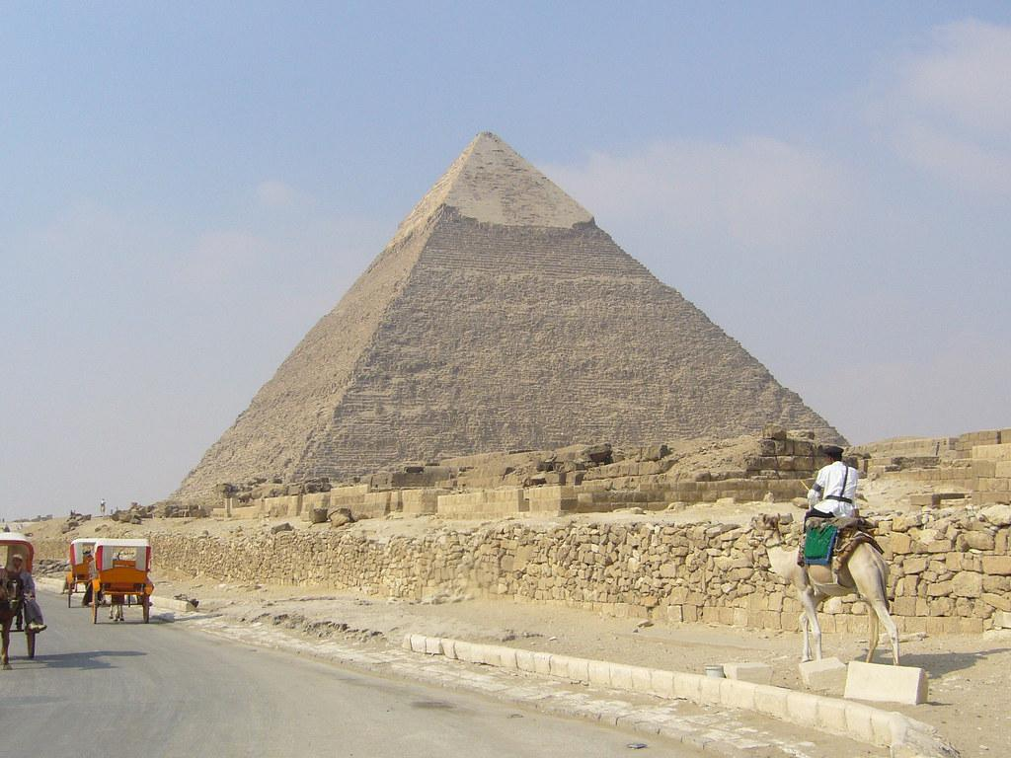

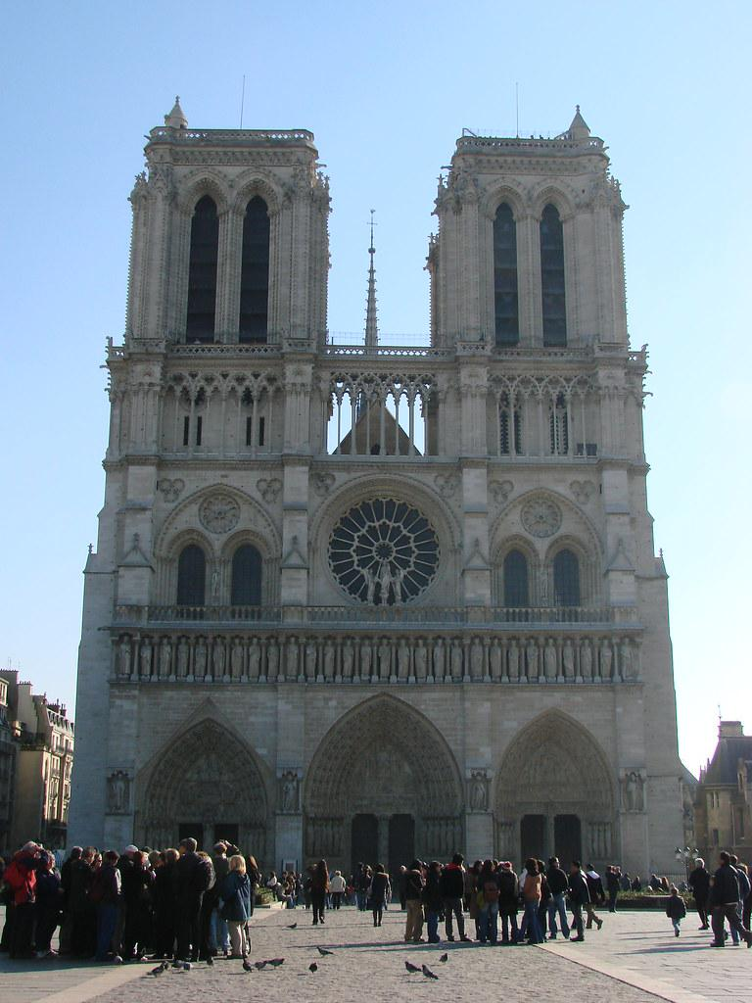
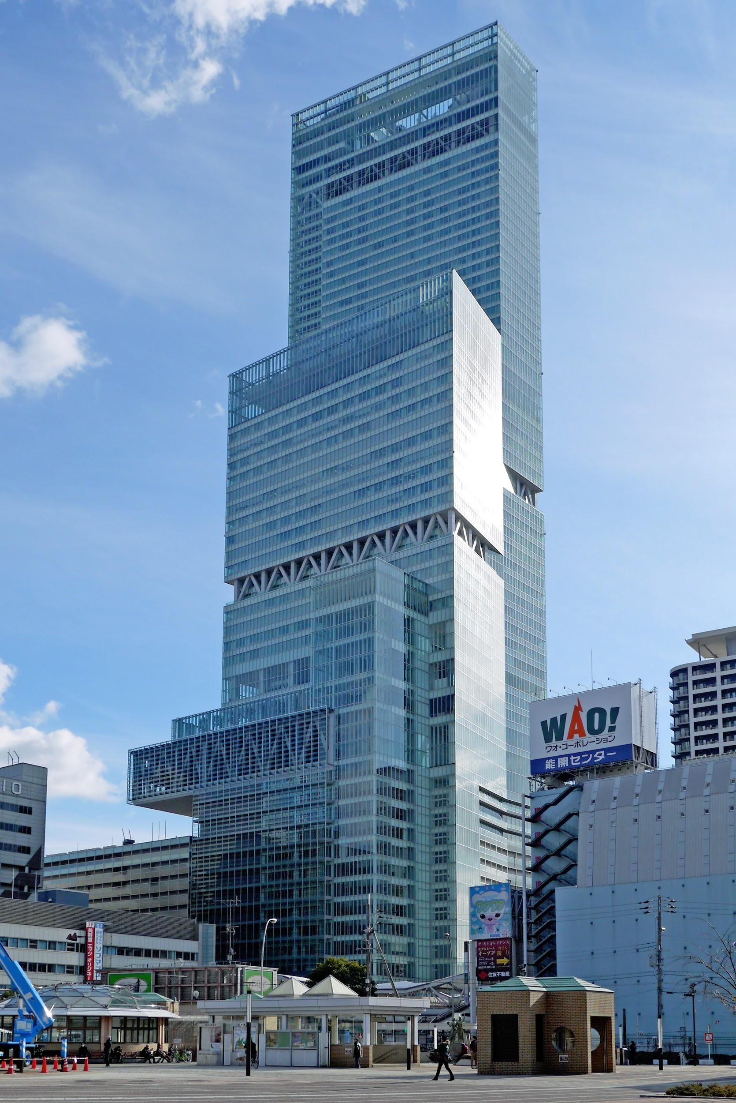
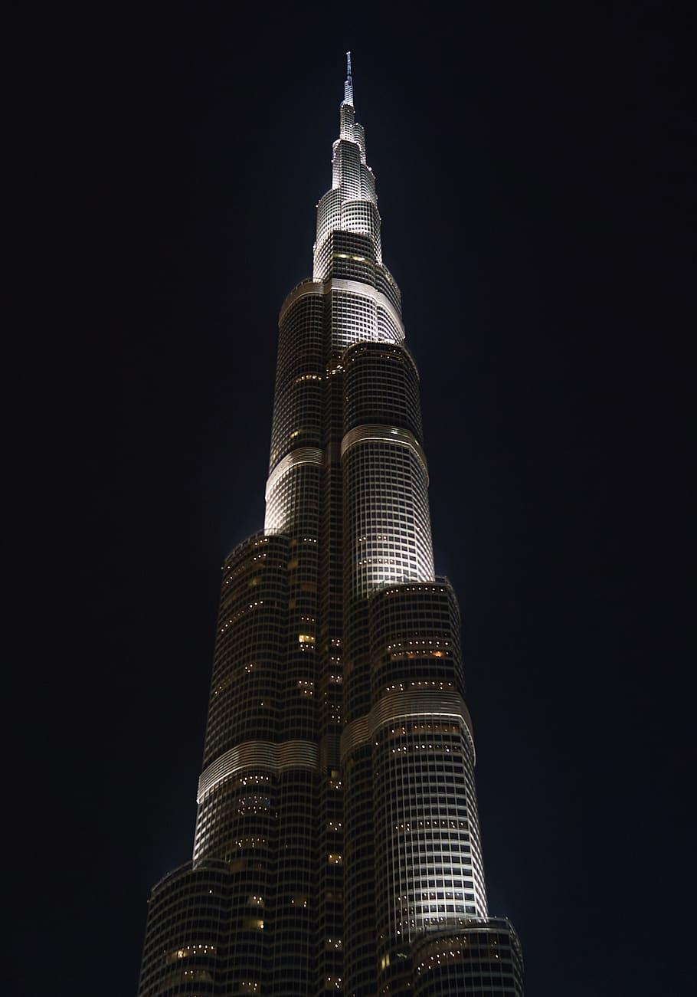
Giza Pyramid The Statue of Liberty Eiffel Tower

Nortre-Dome Cathedral Abe no Harukasu Burj khalifa

History (Old) ±50 years "2pairs"
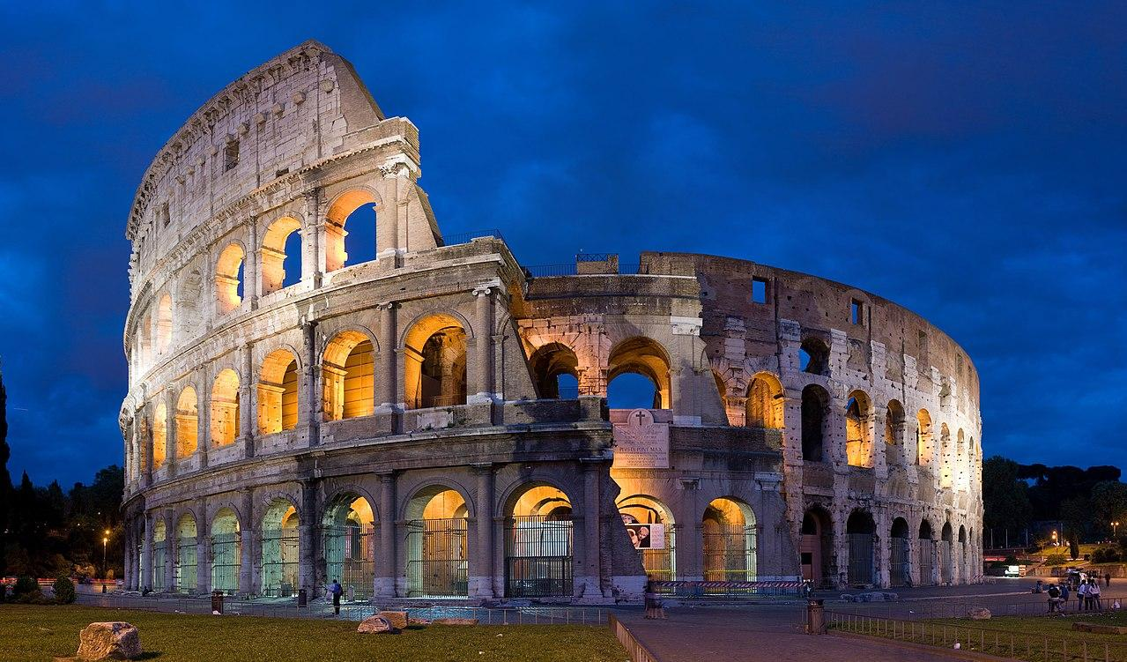

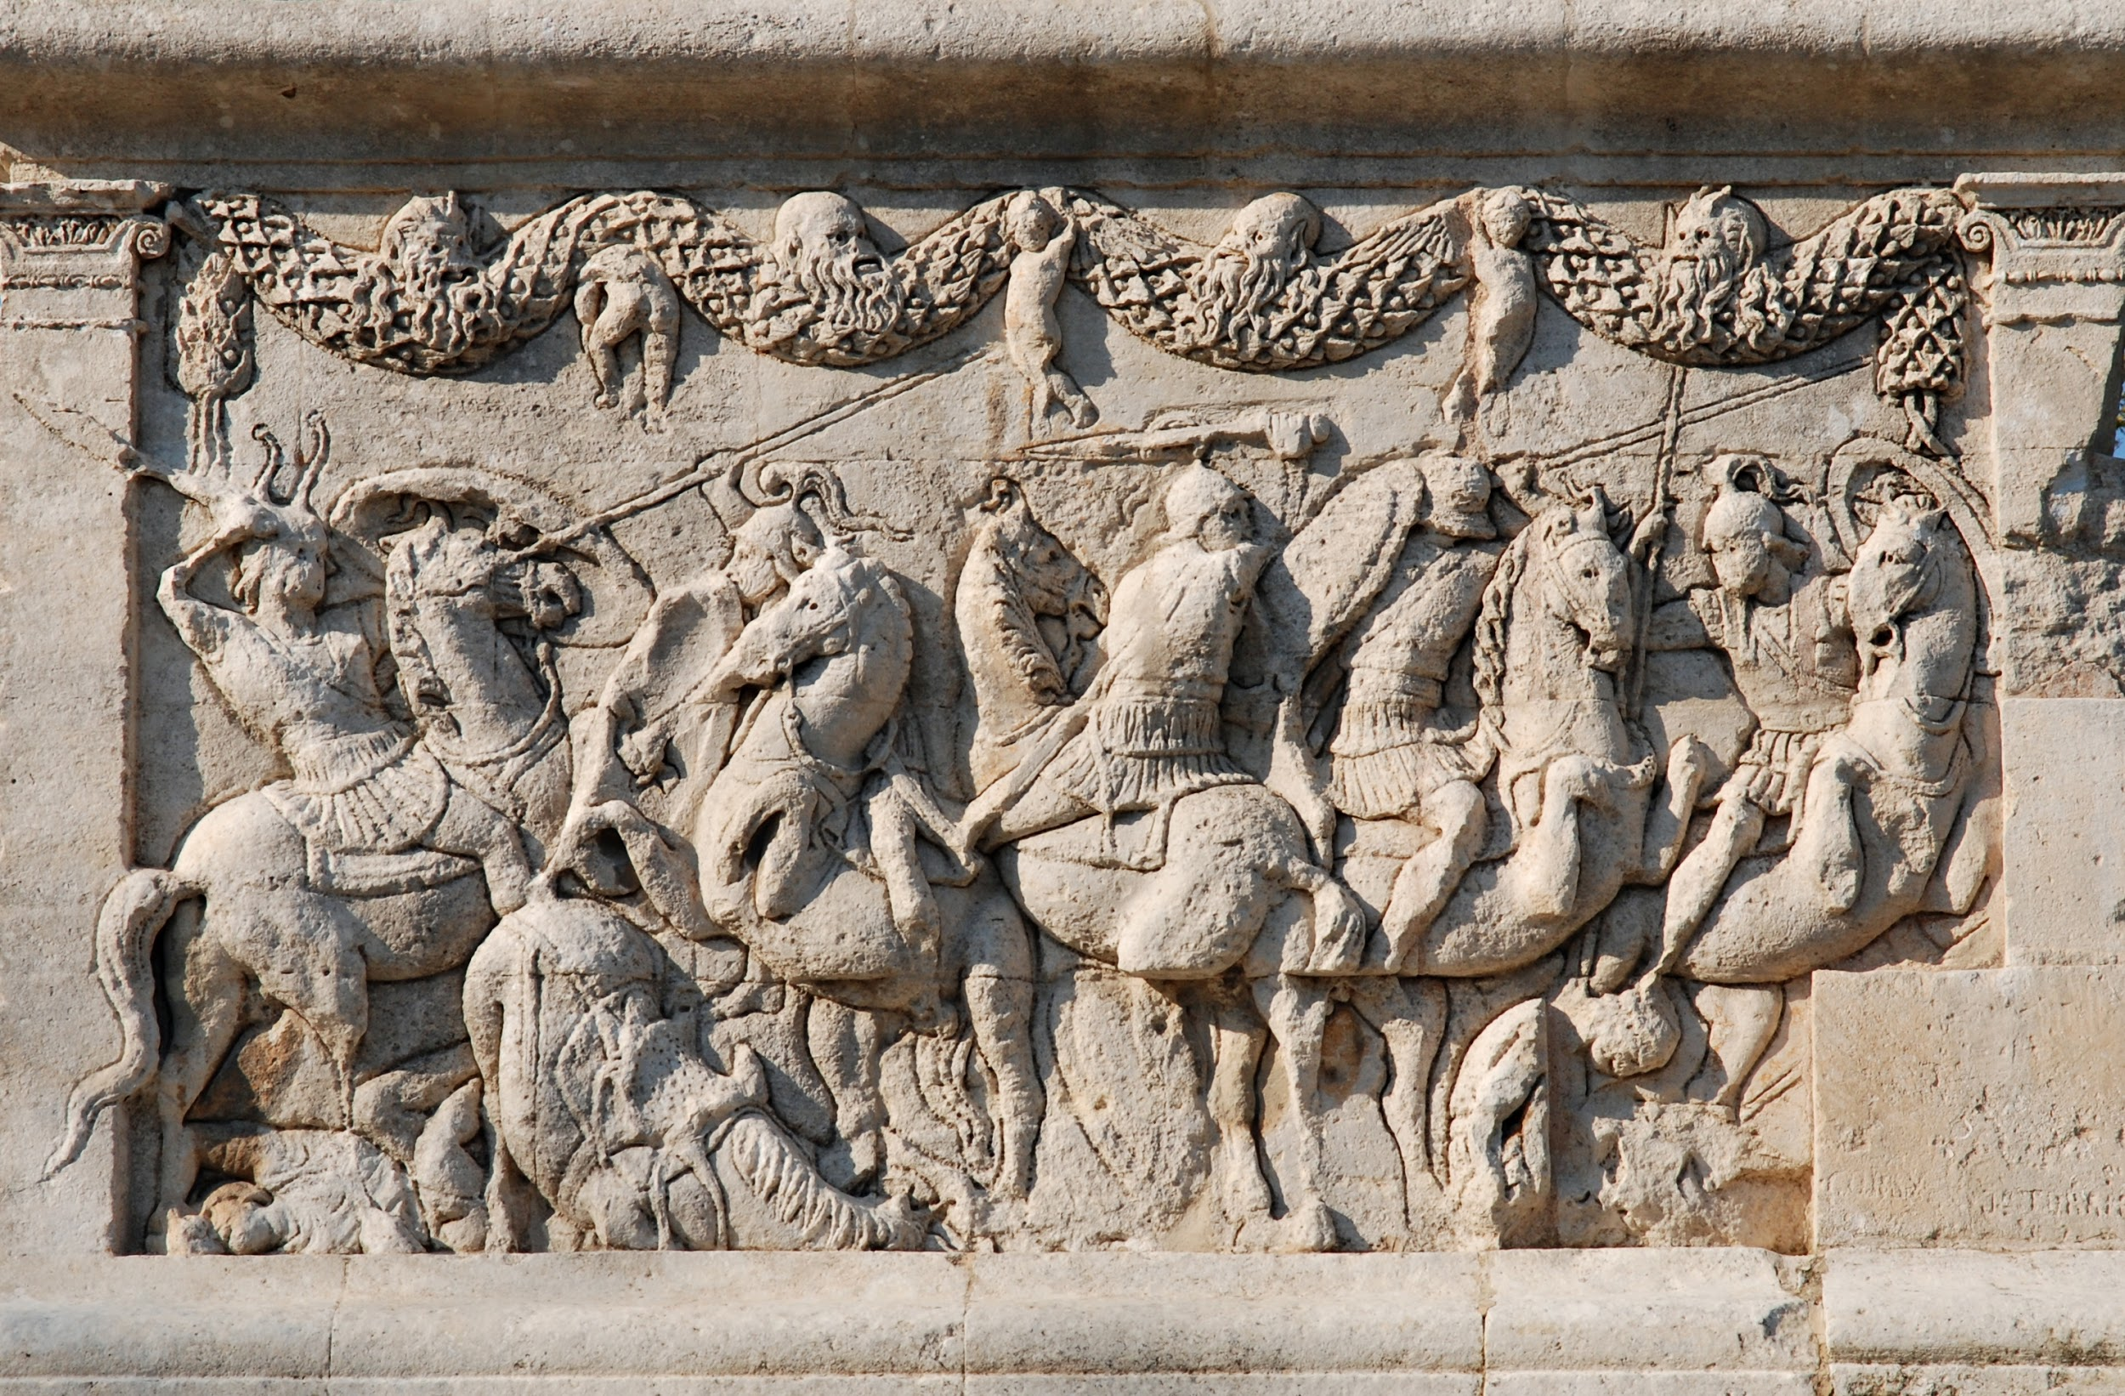

Colosseum Thermae Nero Big ben
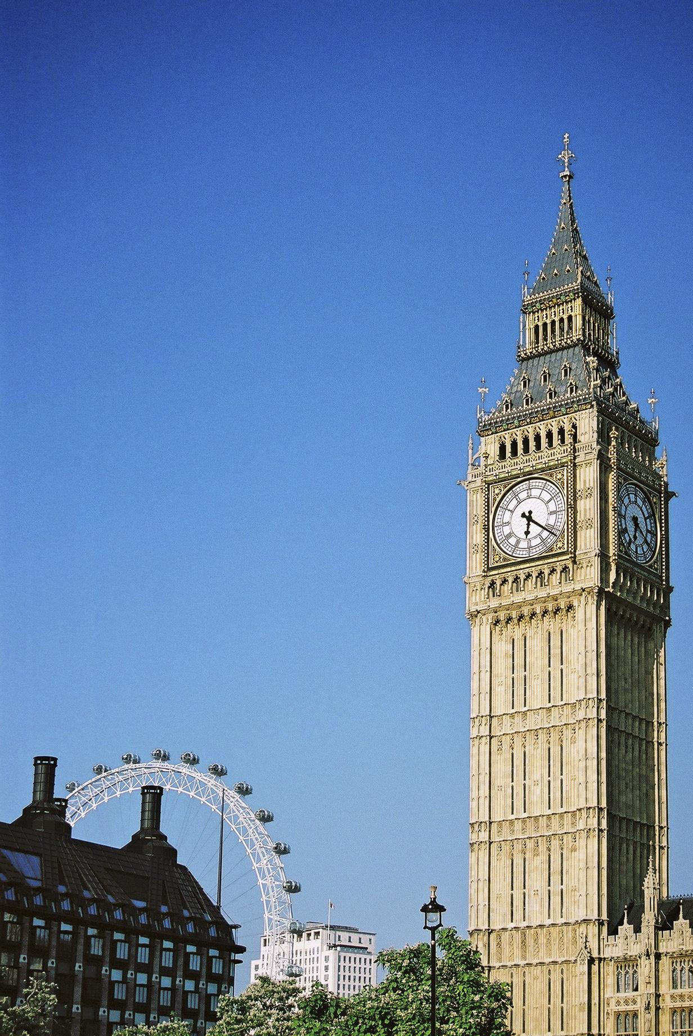
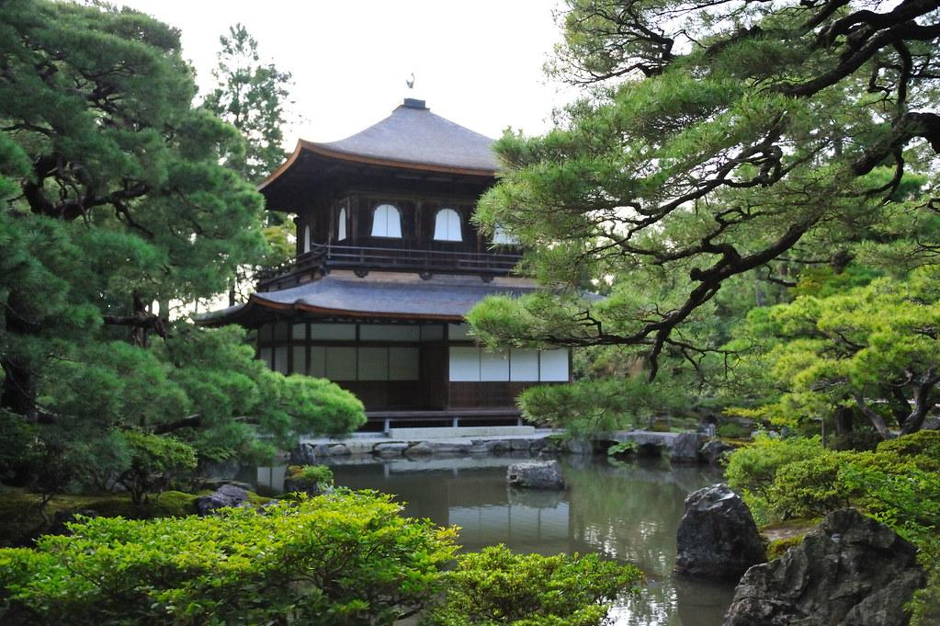
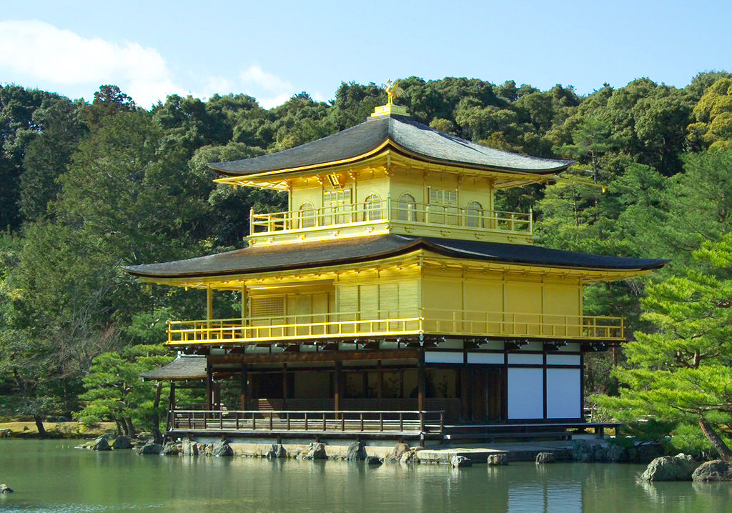

Kinkaku-Temple Ginkaku-Temple Elizabeth Tower

STEP5 まとめ

今日やったことを思い出して自分で文を作ってみよう

（ ）

