〜人物紹介〜
NAME CLASS
~STEP1~
あなたは熱海の中学校に転校してきました。友達のクラス紹介を聞いてわかったことを表にまとめてみよう。
① | ② | ③

~STEP2~
話をもう一度聞いて正しい方に丸をつけよう。

1. Can you see a man in front of the door? His name is Yuto.
He ( have / has ) lived in Ajiro since 2010.

2. Yuko is talking with our teacher, Iwasaki. She is the captain of our soccer club team.
She ( has / have ) played soccer for two years.

3. We are Atami Junior High School Students.
We have a school festival next week, so we ( have / has ) had a lot to do since last Sunday.

~STEP3 Noticing~
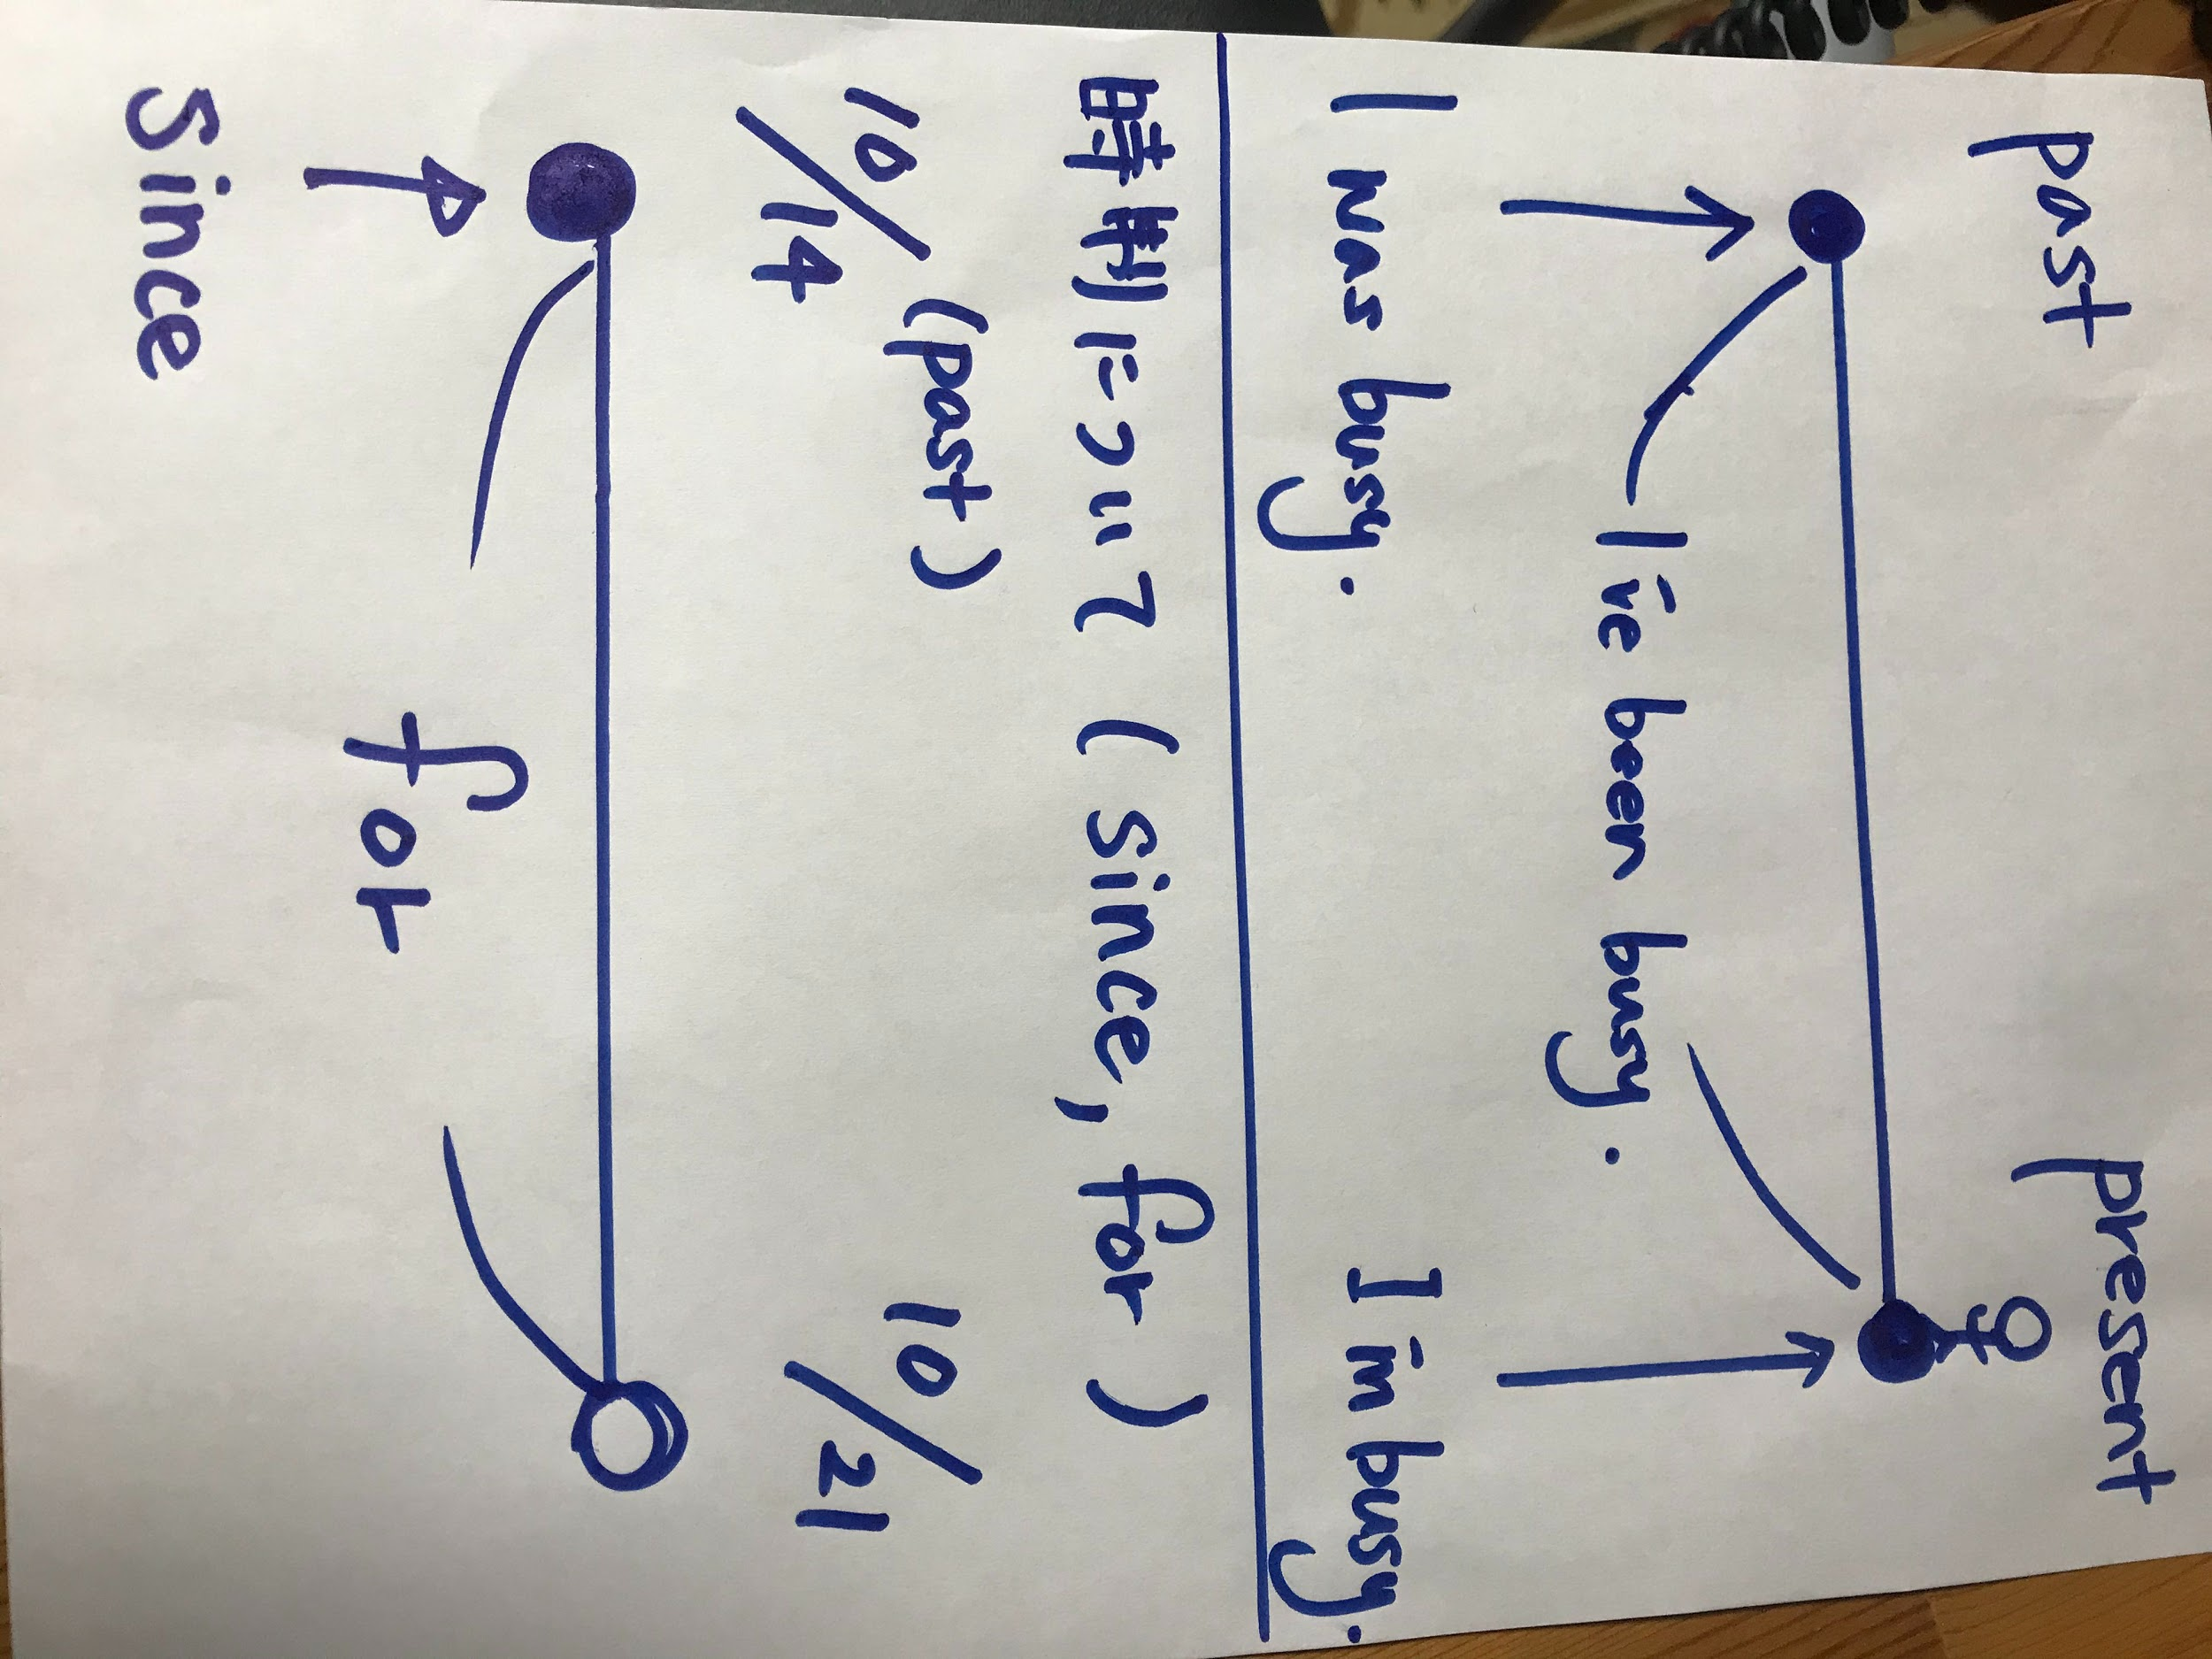
気づいたことをまとめよう。
現在完了のもう一つの使い方。

have + 過去分詞 + 〜〜 で
その状態の( ) を表す。

for ( ) / since ( )

Ex) I have been busy for three weeks.

和訳

~STEP4~
今回習った用法を使ってお気に入りの人・物の紹介をしよう。

EX)
 | His name is Ayase.  He has played the piano since he was 5 years old,  Now, he has worked as a producer of YOASOBI with  Rira Ikuta since November of 2019.

①例を参考にお気に入りの人・物を継続用法を使って紹介してみよう。
（できたら for と since を両方使って紹介してみよう）
Draw a Picture | explanation

②ペアになってクラスメイトとシェアしよう

Hello, ~~~. Today, I will introduce my favorite ~~~.
(show the picture to your pair) He / She / This is ~~~~~~~~~~~~~~~~~~~~~~~

(change the roles)

③ペアの話を聞いてわかったことを次にまとめよう。
ペア1： | ペア2： | ペア3：

